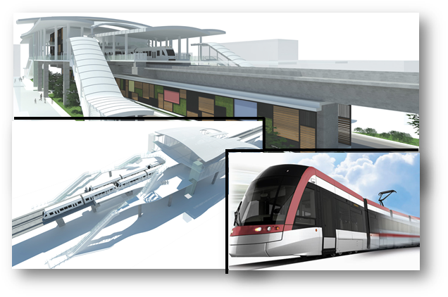

**PT Wijaya Karya (Persero), Tbk.**

**JAKARTA LRT PROJECT – CORRIDOR 1 (PHASE 1):**

**KELAPA GADING–VELODROME – PACKAGE P102**

**MAIN WORKS**

**SCADA**

**DETAIL DESIGN OF HMI**

**Doc. No. WIKA-P102-ALL-440-DSR-0002**

2017

**Validation Sheet**

**SCADA**

**DETAIL DESIGN OF HMI**

**Doc. No. WIKA-P102-ALL-440-DSR-0002**

PROJECT NAME : CONSTRUCTION OF LRT CORRIDOR 1 (PHASE1): KELAPA GADING – VELODROME

PACKAGE NO.102: MAIN WORKS (P102)

DATE : JULY 2017

CONTRACTOR : PT WIJAYA KARYA (PERSERO), Tbk.

This document is issued to those who commissioned and for a specific purpose related to the above projects alone. This document should not be relied upon by any other party or used for other purposes.

We are not responsible for the consequences of this document serve as a reference by the other party, or used for other purposes, or contain errors or omissions caused by errors or *omissions* in the data provided to us by other parties.

This document contains confidential information and intellectual property. This document may not be disclosed to other parties without consent from us and from the party which commissioned it.

|  |  |  |  |  |  |
| --- | --- | --- | --- | --- | --- |
|  |  | **PT WIJAYA KARYA (PERSERO), TBK.** | | | |
| Acknowledge: | Verified by: | Acknowledge: | Reviewed by: | Checked by: | Author/Designer: ***PT. Len*** |
| Name | Name  **Zulkifli Y.** | Name  **Sonny Setiawan** | Name  **Iden Ho** | Name  **SJ. Hong** | Name  **M. Taufik** |
| Position | Position  **Project Manager** | Position  **Project Director** | Position  **Senior Design Manager** | Position  **System Design & Cons. Manager** | Position  **SCADA Engineer** |
| Date: | Date: | Date: | Date: | Date: | Date:  04 September 2017 |

Revision history

|  |  |  |  |  |  |  |
| --- | --- | --- | --- | --- | --- | --- |
| Rev | Date | Reason of Issue | Author | Checked | Approved  WIKA ICE | |
| A | September 04, 2017 | First Submission | M. Taufik |  |  |  |
|  |  |  |  |  |  |  |
|  |  |  |  |  |  |  |

LIST OF CONTENTS

VALIDATION SHEET I

LIST OF CONTENTS III

LIST OF TABLES VI

LIST OF FIGURES VII

ABBREVIATION IX

1. Introduction 1

1.1 Overview 1

1.2 Objective 1

1.3 Scope of Work 1

1.4 Structure of Document 2

1.5 References 3

1.5.1 Document References 3

1.5.2 Standard References 4

2. System Description 5

1.6 SCADA System Overview 10

1.6.1 Functional Role 10

1.6.2 Interdependencies 11

1.6.3 External Interaction 11

1.6.3.1 Backbone System 11

1.6.3.2 M&E Plant and subsystem Server 12

1.7 External System Device Overview 12

1.7.1 Network Switch 12

1.7.2 Network Requirements 12

1.7.3 Routing and Subnets 13

1.7.4 Time Management 13

1.7.5 Power Requirements 14

1.7.6 Surge Protection 14

1.7.7 Bandwidth Utilization 14

3 Hardware Descriptions 16

3.1 OCC SCADA Server PC 16

3.1.1 OCC HMI Workstation PC 17

3.1.2 HMI Workstation Monitor 18

3.1.3 Color Printer 19

3.1.4 Black and White Printer 20

3.2 Typical Station 21

3.2.1 Local SCADA Server 22

3.2.2 Local SCADA PC 23

3.2.3 Workstation Monitor 23

4 Software Functionality 25

4.1 Zenon Product Family 25

4.2 Zenon Editor 26

4.3 Zenon Runtime 28

4.4 Zenon HMI Feature 29

4.4.1 Historian 29

4.4.2 Chronological Event List 31

4.4.3 Automatic Line Coloring (ALC) 32

4.4.4 Alarm Administration 33

4.4.5 User administration 34

5 Supplementary Functions 36

5.1 Redundancy 36

5.2 SIL 2 Safety Application 38

5.3 Signalling Driver 39

5.4 ONVIF Driver 41

6 Project Specific Configuration 44

6.1 General 44

6.2 Control Philosophy and Hierarchy 45

6.2.1 Control Console Permission 45

6.2.2 Operation Control Hirarchy 47

6.2.3 OCC Operating Console 48

6.2.4 Local Operating Console 48

6.2.5 Video Wall Display 49

6.3 I/O List 49

6.4 SCADA System Design and Functionality 50

6.4.1 Archive 50

6.4.2 Alarm 52

6.4.3 Screen Display Design 54

6.4.3.1 Home Screen Display 55

6.4.3.2 BMS Screen Overview 57

6.4.3.3 Power Main Screen 59

6.5 SCADA - Signalling System Design and Functionality 62

6.6 SCADA - Traction Power Substation Design and Functionality 64

6.6.1 Emergency DC Mass Trip System 66

6.7 SCADA - Building Management System (BMS) Design and Functionality 67

6.8 SCADA - PA/PID/VoIP/PHP System Design and functionality 69

6.8.1 SCADA - Public Announcement (PA) System 70

6.8.2 SCADA - Public Information Display (PID) 72

6.8.3 SCADA - VoIP and Passanger Help Point (PHP) 73

6.9 SCADA - AMS/CCTV System Design and Functionality 74

6.10 SCADA - Other System design 75

6.11 SCADA Wall Display Design 76

6.12 HMI SCADA Sytem BoQ 78

6.13 Cabling System 75

6.13.1 CAT 6 Cable 75

6.13.2 AC Power Cable 4 Core 75

6.13.3 Earthing Cable 76

6.14 Earthing System 77

6.14.1 Introduction 77

6.14.2 Grounding of SCADA Equipment 77

7 Electromagnetic compatibility 79

8 RAMS Model 75

9 Appendix 78

Appendix A: Compliance List Matrix 78

Appendix B: List of Drawings 78

Appendix C: SIL 2 Certificate 78

Appendix D: Technical Spesification of SCADA 78

Appendix E: IO List (not confirm) 78

# LIST OF TABLES

Table 1 – Document References 3

Table 2 – SCADA Functional Device Types 10

Table 3 – SCADA System Bandwidth Utilization 15

Table 4 – Technical Spesification HPE ProLiant DL 380 Gen 9 17

Table 5 – Technical Specification HP Z440 Workstation 17

Table 6 – Zenon Editor Interface Element 28

Table 7 – Zenon Runtime Minimum Requirements 29

Table 8 – SCADA IO List 50

Table 9 – storage the form of Archive in SCADA Server 51

Table 10 – SCADA System alarm list display 53

Table 11 – BMS and SCADA Controlling and Monitoring List 69

Table 12 – SCADA Interface with other Party 75

Table 13 – CAT 6 Cable's Spesification 75

Table 14 – Tehnical Cable's Spesification for AC Power 76

Table 15 – Technical Cable's Spesification for Power and Chassis Grounding 77

Table 16 – Equipment MTBF, MTTR and Availability Summary 75

# LIST OF FIGURES

Figure 1 – SCADA System Overview 9

Figure 2 – HP Z440 Workstation 17

Figure 3 – HP N240 24-inch 18

Figure 4 – HP Color Laserjet Pro M177fw 19

Figure 5 – HP Pro 3610 Black and White E 20

Figure 6 – Station Arcitecture Diagram 21

Figure 7 – HPE ProLiant DL 180 Gen 9 22

Figure 8 – HP Z440 Workstation 23

Figure 9 – HP N240 24-inch 24

Figure 10 – Zenon Editor Interface 27

Figure 11 – Zenon Report Generator Feature 30

Figure 12 – Zenon Report Viewer Feature 31

Figure 13 – Zenon ALC Example 33

Figure 14 – User administer configuration table 35

Figure 15 – Zenon Software Redundancy Example 37

Figure 16 – Signalling Driver Block Diagram 39

Figure 17 – CTC – SCADA Data Flow Control 40

Figure 18 – Web Service WSDL System Overview 41

Figure 19 – ONVIF Profile S Flow Control 43

Figure 20 – Remote/Local Permissive mechanism 46

Figure 21 – Home Screen Display 55

Figure 22 – BMS Status Display 56

Figure 23 – BMS Failure Status Display 58

Figure 24 – Main Power Home Screen 60

Figure 25 – 20kV Screenshot 61

Figure 26 – SCADA and Signalling System Connection diagram 62

Figure 27 – SCADA and Signalling System Operational Concept 63

Figure 28 – SCADA Traction Power Substation Connection Diagram 64

Figure 29 – SCADA System and Traction Power System Operational Concept 65

Figure 30 – Emergency trip button 67

Figure 31 – SCADA System and Building Management System Connection Diagram 68

Figure 32 – SCADA and PA/PID/VoIP/PHP System Connection Diagram 70

Figure 33 – SCADA System and PHP system Operational Concept 73

Figure 34 – SCADA – AMS/CCTV System Connection Diagram 74

Figure 35 – SCADA Connection with Other Party 76

Figure 36 – SCADA Wall Display Design Interface Diagram 77

Figure 37 – Detail of Ground Connection 78

Figure 38 – Ground Bus Bar Connection Details 78

Figure 39 – SCADA System SIL 2 Boundary 75

Figure 40 – SCADA System Configuration 76

Figure 41 – SCADA System Availability calculation 76

ABBREVIATION

| Term | MEANING |
| --- | --- |
| SCADA | Supervisory Control and Data Acquisition |
| LRT | Light Rail Transit |
| SIL | Safety Integrity Level |
| TPSS | Traction Power SubStation |
| APSS | Auxiliary Power SubStation |
| BMS | Building Management System |
| PA | Public Address |
| PID | Passenger Information Display |
| PHP | Passenger Help Point |
| CCTV | Closed-Circuit Television |
| AMS | Access Management System |
| OCC | Operation Control Center |
| HMI | Human Machine Interface |
| RTU | Remote Terminal Unit |
| IO | Input/Output |
| M&E | Mechanic and Electric |
| NTP | Network Time Protocol |
| OA | Open Access Sdn. Bhd. |
| GUI | Graphic user Interface |
| UDP | User Datagram Protocol |
| QoS | Quality of Service |
| SAT | Site Acceptance Test |
| SDK | Software Development Kit |
| Zenon | SIL 2 Certified SCADA HMI Software by Copadata |
| Zone | Audio Zone – a number of audio outputs which can be controlled (audio content, volume level, ANC) as a group |
| SNI | Standard National Indonesia |

# Introduction

* 1. Overview

PT Len Industri has been engaged to deliver the SCADA system for the Jakarta LRT Project which will be SIL 2 certified based on IEC61508.. This system is an integrated SCADA system for both monitoring and control (some system) for the following railway systems:

* Power System including TPSS ,APSS and 3rd Rail
* Automatic Fare Collection
* Building Managemen System (BMS)
* Telco equipment, PA, PID, PHP, Radio Tetra, CCTV and AMS
* Signalling SystemPlatform Screen Door (PSD)

The fixed infrastructure project comprises 6 stations and a Depot which includes the OCC and BCC.

* 1. Objective

This document is intended to capture and describe all system requirements and required behaviour relating to the SCADA System to be supplied for the Jakarta LRT project, focusing on the HMI design. This document focused on the Design and Functionality of the system.

* 1. Scope of Work

PT Len is the leader for SCADA system in this project. PT Len is overall responsible of the  
design with the engineering process assisted by Vendor.

The scope of supply includes:

* Supply of OCC SCADA Server (also redundant server) hardware and software
* Supply of OCC SCADA HMI workstation hardware and software
* Supply of OCC color printer
* Supply of OCC black and white printer
* Supply of Local SCADA Server (and redundant server) hardware and software
* Supply of Local SCADA HMI Workstation hardware and software
* Supply of Local RTU redundant I/O
* Design of software functional additions
* Project Management related to supply and integration
  1. Structure of Document

The document divided into 9 Section

Section 1. Introduction

Section 2. System Description

Section 3. Hardware Description

Section 4. Software Functionality

Section 5. Supplementary Functions

Section 6. Project Specific Configuration

Section 7. Electromagnetic Compatibility

Section 8. RAMS Model

Section 9. Appendix

## References

* + 1. Document References

|  |  |  |  |
| --- | --- | --- | --- |
| **#** | **Document ID** | **Document** | **Source** |
| **1** | 362748-MMI-MVI1-XX-SP-000-0010 dated 05.09.2016 | Technical Specification | Tender Document |
| **2** | 362748-MMI-MVI1-XX-SP-000-0001 dated 20.05.2016 | Design Criteria | Tender Document |
| **3** | 362748-MMI-MVI1-XX-RP-760-0001 | Interface Matrix | Tender Document |
| **4** | 362748-MMI-MVI1-XX-RP-781-0001 | Safety Hazard Log | Tender Document |
| **5** | 362748-MMI-MVI1-XX-DR-000-0004 | Preliminary Design Report Volume 3 Drawings | Tender Document |
| **6** | Zenon manual: alarm administration v.760 | Zenon Manual | Copa Data |

Table 1 – Document References

* + 1. Standard References

|  |  |  |
| --- | --- | --- |
| **#** | **Standard** | **Description** |
| 1 | BS 7430 | Requirements for electrical installations, lET Wiring Regulations. 17th edition |
| 2 | BS 7671 | Railway applications. Electromagnetic compatibility |
| 3 | BS EN 50121 | Railway applications. Fixed installations. Electrical safety, earthing and the return |
| 4 | BS EN 50122 | Circuit |
| 5 | BS EN 50125 | Railway applications. Environmental conditions for equipment |
| 6 | BS EN 50126 | Railway applications. The specification and demonstration of reliability, |
| 7 | BS EN 50128 | Railway applications. Communication, signalling and processing systems. Software for railway control and protection systems |
| 8 | BS EN 50129 | Railway applications. Communication, signalling and processing systems |
| 9 | BS EN 50174 | Information Technology. Cabling installation |
| 10 | BS EN 50288-7 | Multi-element metallic cables used in analogue and digital communication and control |
| 11 | BS EN 50310 | Application of equipotential bonding and earthing in buildings with information technology equipment |
| 12 | BS EN 60073 | Basic and safety principles for man-machine interface, marking and identification. Coding principles for indication devices and actuators |
| 13 | BS EN 60529 | Degrees of protection provided by enclosures (IP code) |
| 14 | BS EN 60617 | Graphical symbols for diagrams |
| 15 | BS EN 60870 | Tele-control equipment and systems |
| 16 | BS EN 60950 | Information Technology Equipment. Safety |
| 17 | BS EN 61000 | Electromagnetic compatibility (EMC) |
| 18 | BS EN 61131 | Programmable controllers |
| 19 | BS EN 61508 | Functional Safety of Electrical/Electronic/programmable electronic safety-related systems |
| 20 | BS EN 62305 | Protection against lightning |
| 21 | BS EN 62491 | Industrial systems, Installations and equipment and industrial products — labelling of cables and cores |
| 22 | ISO 11801:2012 | Information technology - Generic cabling for customer premises - Amendment 2 |
| 23 |  | All Indonesia National and Municipal Codes, Acts and Regulations that are related  to the SCADA system |

# System Description

The SCADA system scope in The Jakarta LRT Project include provision of a centralised control function with appropriate SCADA facilities to provide the Operators with an efficient means of real-time monitoring and controlling the M&E plant and subsystems throughout the stations through the SCADA workstations.

The core of the SCADA system will comprise a pair of redundant servers, configured in a hot-standby configuration to provide resilience and secondary recovery control positions. The primary server is installed in the common equipment room of OCC, while the back up server is installed in the emergency recovery centre i.e BCC. The SCADA servers is configured in a hot-standby arrangement so that either server can immediately assume system mastership in the event of one server failure. It is possible to remove one server for maintenance without interrupting system operation and, upon its reinstatement, re-synchronize the database without interruption to system operations. The Operator is able to designate either server as the primary or secondary server through the SCADA workstations.

Each server is designed to have two communication links to interconnect with two different network switches for receiving or transmitting I/O status from or to the fields RTUs, SCADA workstations or subsystems.

The SCADA system is designed to continuously monitor the status of M&E plant and subsystems at the following locations:

* All stations
* Depot
* Traction Power Substations

Equipment failures of M&E plant and subsystems shall generate alarms to the SCADA workstations which shall be automatically recorded and printed.

The SCADA servers is capable, in terms of processor and memory, to meet the performance requirements, including operator interface, database management, alarming and communication interfaces. The primary server is designed to handle communications with the RTUs, maintain the primary system database and interface with the SCADA workstations through the LAN in OCC or Fibre Optic Transmission System for those SCADA workstations that installed throughout the stations.

The SCADA servers is designed to utilise the LAN connection to monitor and control of other subsystems including CCTV System, Public Address (PA) System, Help Points System, Passenger Information Display (PID) System, etc. through the IP protocol.

The secondary server is designed to provide identical functions as primary server, including data storage and data printing. Furthermore, the secondary server can take over the primary server’s function immediately without re-booting when a primary server failure occurs. The secondary server shall update the primary server’s database and handover the supervisory and control function back to the primary server once it has recovered.

Each SCADA workstation at OCC is designed to accommodate with four monitors. One monitor shall be dedicated to display CCTV images (spot monitor), and three monitors shall be used to display GUI graphics for overview stations display, overview traction power substations display and alarm status display for control and monitoring.

Each station is installed with a Local SCADA workstation that has the same basic system operations and functionality of the OCC SCADA system. Each Local SCADA workstation is designed to accommodate with two monitors. Two monitors shall be used to display GUI graphics for overview station display and alarm status display of the particular station.

All SCADA servers and workstations is configured with password access levels so that access to the operating control level is available only to Operator with the appropriate access rights.

OCC HMI Workstations is comprised of colour monitors with a minimum size of 23.8”, diagonal non-glare flat LED screens and have a minimum resolution of 1920 X 1080 pixels. The SCADA workstations is designed to display with colour GUI diagrams the current status of the M&E plant and subsystems.

Two black ink laser printers is provided in OCC room. One printer shall be assigned for printing of recording alarms or event transactions, and the other printer shall be configured as standby. A colour laser printer that supports GUI graphics shall be provided and shall be assigned for printing of system reports and trending.

The SCADA system using the Remote Terminal Units (RTUs) to gather I/O status of M&E plant and subsystems from various stations. Each location shall consist of redundant I/O device. Each set of RTU is powered from dual power supply units to achieve system availability. Each set of RTU is designed to comprise dual communication modules to interconnect with different network switches (diverse LAN route) for transmitting the received I/Os to the SCADA system. The Fibre Optic Transmission System is used to link the RTUs at various locations back to the SCADA servers at depot. The RTUs for the substations is linked via a dedicated fibre optic cable to the nearby station for retransmission of I/Os back to the SCADA servers.

The below provides an overview of the system.







Figure – SCADA System Overview

## SCADA System Overview

### **Functional Role**

The following functional types of devices will be used as part of the SCADA system for the Project as identified in table below

|  |  |  |  |
| --- | --- | --- | --- |
| **No** | **Functional Device Type** | **Device** | **Model** |
| 1 | OCC SCADA Server | HP | HPE ProLiant DL 380 Gen 9 |
| 2 | OCC HMI Workstation | HP | HP Z440 Workstation |
| 3 | OCC HMI Monitor | HP | HP N240 24-inch |
| 4 | Colour Printer | HP | HP Colour Laserjet Pro M177fw |
| 5 | Black/White Printer | HP | HP Pro 3610 Black and White E |
| 6 | Local SCADA Server | HP | HPE ProLiant DL 180 Gen 9 |
| 7 | Local HMI Workstation | HP | HP Z440 Workstation |

Table 2 - SCADA Functional Device Types

1. OCC SCADA Server responsibility are including operator interface, database management, alarming and communication interfaces. The primary server responsibility also to handle communications with the local SCADA server, maintain the primary system database and interface with the SCADA workstations through the LAN in OCC or Fibre Optic Transmission System for those SCADA workstations that installed throughout the stations.
2. OCC HMI Workstation is comprised of four monitors. It is designed to display with colour GUI diagrams the current status of the M&E plant and subsystems. One monitor shall be dedicated to display CCTV images (spot monitor), and three monitors shall be used to display GUI graphics for overview stations display, overview traction power substations display and alarm status display for control and monitoring.
3. Black/White Printer assigned for printing of recording alarms or event transactions, and the other printer shall be configured as standby. A colour laser printer that supports GUI graphics shall be provided and shall be assigned for printing of system reports and trending.
4. Local SCADA Server responsibility is to handle communications with the RTUs, communication with OCC SCADA Server and interface with the SCADA workstations in each local station.
5. Local HMI Workstation is designed to accommodate with two monitors. The monitor shall be used to display GUI graphics for overview station display and alarm status display of the particular station.
6. Local RTU redundant I/O main function to gather I/O status of M&E plant and subsystems from each station and send it to local SCADA Server.

### **Interdependencies**

When operating in a networked configuration, all SCADA system equipment are managed and communicate with OCC SCADA Server. In this operation mode, all the Local HMI Workstation display only mimicking the SCADA HMI Workstation.

Local SCADA Server at a location are also capable of operating in a degraded mode (“standalone” mode) when there is no network connectivity to the OCC SCADA servers. In this mode, Local SCADA Server will independently manage the communication with RTUs and control equipment in local station.

OCC SCADA Server will be supplied for the Jakarta LRT Project. The two servers provide a fault tolerant configuration where system operation will be coordinated by the secondary server in the event of a fault, power input, or network connectivity to the primary server. The servers will be installed in two separate locations. The primary SCADA server shall be installed in the OCC Equipment Room, while the secondary SCADA server shall be installed in the BCC Equipment room.

### **External Interaction**

The SCADA system supports operating in a networked configuration. It is intended to configure the system from the outset with the expectation of a network being provided. Each equipment (Servers, Workstations and RTUs) requires an IP connection for transfer of control and media content information. Furthermore, via the network system, external interactions with third party system can also be accomplished as further described below:

* + - 1. Backbone System

SCADA System requires the following information to be determined for each device:

* UDP and TCP/IP Networking
* Addressing assignment method (DHCP, Auto or Static)
* IPv4 Address and network subnet (for Static / Auto)
* Default Gateway Address Details (for Static / Auto)
* NTP Server Addresses

How the alarm being monitored i.e. SNMP must be mentioned here. The list of alarm shall be refrenced to the Appendix….

* + - 1. Public Address System

For the Jakarta LRT project, it is required for the SCADA system to be able to monitor and control the PA system. This shall be achieved by allowing the SCADA system access to the open access SDK, with which an relevant GUI shall be created within the SCADA system to allow for specific monitoring and control of the PA system.

Among the control that shall be available to the SCADA operators:

* Control of the initiation and end of a Live PA stream including zone, priority and location selection
* Control of the initiation and end of a DVA stream including zone, priority and location selection
* Control the trigger of the automatic DVA announcement based on train locations/arrival/departure
* Control the trigger of automatic DVA announcement based on schedules
* Managing system operational configuration and settings (such as volume control)

Among the monitoring capabilities that shall be available to the SCADA operators:

* Monitoring of PA system alarms and faults
* Monitoring of PA system health status
* Monitoring of PA system speaker health
* Monitoring of PA zones status
  + - 1. PIDS
      2. VoiP Telephone
      3. Radio System
      4. AFC
      5. PSD
      6. Signalling
      7. Etc
      8. M&E Plant and subsystem Server

SCADA system located in OCC will interact with several M&E Plant and subsystem via server to server communication listed below:

* PABX Server
* AFC Server
* Radio System Server
* Backbone and Access Server
* NTP Server
* PA, PIDS & PHP Server
* CTC/Signal Server

Beside the server to server communication SCADA System in OCC will also interact with other system listed below:

* BMS RTU/Processor
* Allen Bradley Redundant I/O
* APSS Protection Relay

In other hand, SCADA System located in various station will interact with system listed below:

* BMS RTU/Processor
* Allen Bradley Redundant I/O
* TPSS Protection Relay

## External System Device Overview

### **Network Switch**

The Customer will provide Ethernet switches required for the fixed infrastructure network.

### **Network Requirements**

The network is recommended to have the following features and protocols:

* UDP and TCP/IP Networking
* 802.1Q VLAN Support
* Provision of an NTP time source
* DHCP Option 82 (if DHCP is used for SCADA devices)
* SNMP
* ModBus TCP
* IEC-61850
* ODVA
* OPC UA
* Open Access SDK
* DAEATI Signal Protocol

### **Routing and Subnets**

A networked system requires the following network topology and structure to be provided:

* OCC SCADA Server network path should be the same path used by OCC HMI Workstation.
* Local SCADA Server network path should be the same path used by Local HMI Workstation.
* Firewalls are not recommended to be installed between SCADA subsystem unless carefully configured.
* A contiguous range of UDP ports is required for RTP audio streams.

### **Master Clock - Time Management**

The SCADA system requires access to a NTP timeserver for reliable time synchronization. It is recommended that the SCADA System networking infrastructure for all operations and all network management is consistent.

The SCADA system are configured to act as Stratum 3 or higher NTP server and are recommended to be configured so that they interface to an NTP server in the network. All announcement and system events are logged with timestamps at the SCADA Server. NTP ensures there is a synchronized time throughout the whole system in order to provide accurate audit records. No specialised, high precision backup / hold over clocks are provided on the SCADA System therefore drifting and time synchronisation is reliant on NTP.

PT Len is to supply all NTP server details e.g. NTP IP addresses upon commencement of the project. It is expected there will be at least one (1) NTP time source for this project as indicated. In the event the NTP time sources are unavailable, the SCADA servers will continue to act as time servers for higher stratum SCADA equipment during the holdover period. The holdover period is configurable and by default set to at least 1 day.

### **Power Requirements**

230VAC power will be made available for SCADA system devices. Uninterruptable power if required will be provided via UPS supplied by others.

|  |  |  |  |  |  |
| --- | --- | --- | --- | --- | --- |
| **SCADA Equipment** | **Number of Device** | **Power Requirement** | | | |
| **Phase** | **V** | **I** | **Watt** |
| Main Server - HPE ProLiant DL 380 Gen 9 | 2 | 1 | 220 | 4 | 1000 |
| Switch | 12 | 1 | 220 | 0.3 | 50 |
| Workstation - HP Z440 Workstation | 8 | 1 | 220 | 4 | 800 |
| LED Monitor - HP Z24i | 20 | 1 | 220 | 1 | 200 |
| HP Colour Laserjet Pro M177fw | 1 | 1 | 220 | 1.5 | 300 |
| HP Pro 3610 Black and White E | 2 | 1 | 220 | 0.3 | 50 |

### **Surge Protection**

No lightning surge protection is included in the scope of this project. Surge protection equipment is expected to be supplied by others where required. Open Access can recommend in-rush current and continuous current used by devices to assist in the selection of surge protection devices.

### **Bandwidth Utilization**

The following table shows estimated bandwidth utilised for communication between different SCADA equipment in the LRT Jakarta SCADA system:

| **Transport Method** | **Bandwidth** |
| --- | --- |
| OCC SCADA Server – OCC HMI Workstation | 100 Mbps |
| OCC SCADA Server – BMS RTU | 100 Mbps |
| OCC SCADA Server – APSS RTU | 100 Mbps |
| OCC SCADA Server – APSS Protection Relay | 100 Mbps |
| OCC SCADA Server – PABX Server | 100 Mbps |
| OCC SCADA Server – AFC Server | 100 Mbps |
| OCC SCADA Server – Radio Sysem Server | 100 Mbps |
| OCC SCADA Server – Backbone and Access Server | 100 Mbps |
| OCC SCADA Server – PA, PID and PHP Server | 100 Mbps |
| OCC SCADA Server – CTC/Signalling Server | 1000 Mbps |
| OCC SCADA Server – NTP Server | 100 Mbps |
| OCC SCADA Server – CCTV and Secutiry Server | 100 Mbps |
| OCC SCADA Server – Local SCADA Server | 100 Mbps |
| Local SCADA Server – Local HMI Workstation | 100 Mbps |
| Local SCADA Server – BMS RTU | 100 Mbps |
| Local SCADA Server – TPSS RTU | 100 Mbps |

Table 3 – SCADA System Bandwidth Utilization

1. Hardware Descriptions

Operation Control System (OCC) is centralised SCADA system to manage a whole power supply, switch position, voltages of the network, power measurements, alarms and all statuses. To manage that work the OCC needs robust and proven technology hardware.

* 1. OCC SCADA Server PC

The proposed hardware for the server in OCC is HPE ProLiant DL 380 Gen 9 as detailed below. We chose commercially avialable hardware from reputable company to ensure the support and evailliblity fo the hardware for th life cycle of the project. This is also in line with standardization of the HP brand across all the system vendors .



Figure 2 – SCADA System Overview

|  |  |
| --- | --- |
| **Operating System** | Windows Server 2016 x64 |
| **Processor** | Intel® Xeon® E5-2637v4, 3.50 GHz, 15M Cache, 4 cores CPU |
| **Memory** | 32 GB (2x HPE 16GB 1Rx4 PC4-2400T-R Kit) |
| **Storage** | HP Smart Array P440ar/2G FIO Controller  2x HPE 300GB SAS 10k SFF SC HDD  12x HPE 600GB SAS 15K SFF SC HDD |
| **FBWC** | 2 GB DDR3-1,866 MHz, 72-bit wide bus at 14.9 GB/s on P440ar |
| **Battery** | HPE DL/ML/SL 96 W Smart Storage Battery optional |
| **HPE SmartDrives** | 24 + 2 SFF/12 + 3 LFF max, HDD/SSD, M.2 enabled and optional 6 NVMe PCIe SSD support |
| **Networking** | HP Embedded 1Gb Ethernet 4-port 331i Adapter |
| **VGA/serial/USB/SD ports** | Front VGA opt, rear VGA, and serial standard, 5 USB 3.0, 2 USB 2.0 optional, Dual microSD optional |
| **Power and cooling** | 2x HPE 800W FS Plat Hot Plug Power Supply Kit |
| **Industry compliance** | ASHRAE A3 and A4,6 lower idle power, and ENERGY STAR |
| **Form factor/Chassis depth** | Rack (2U), 26.75" (SFF) |
| **Serviceability—easy install rails** | Standard |
| **Operating Environment** | Operating temperature: 10 to 35°C  Operating humidity: 8 to 90% RH |
|  |  |

Table - Technical Spesification HPE ProLiant DL 380 Gen 9

### **OCC HMI Workstation PC**

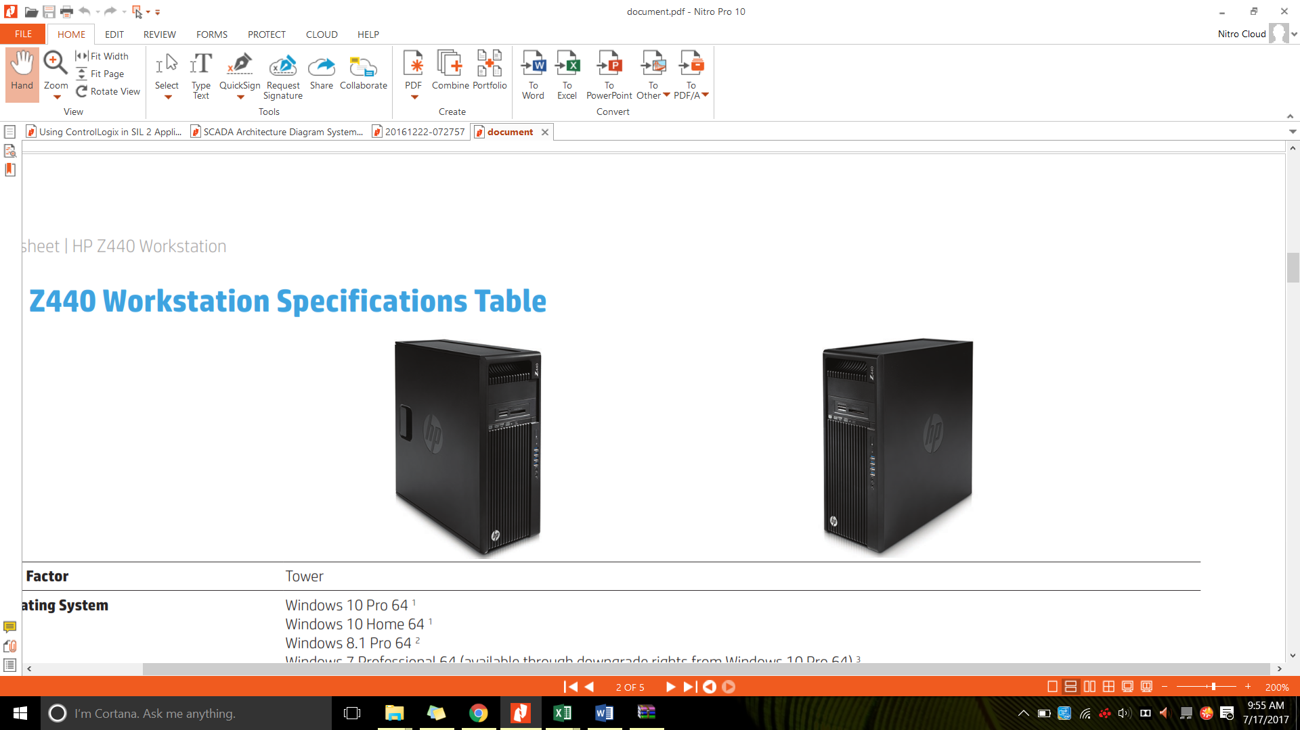

Figure - HP Z440 Workstation

For the client PC, a workstation specification shall be adequate and the proposed hardware is HP Z440 Workstation. The technical specification for HP Z440 is as detailed beow.

|  |  |
| --- | --- |
| **Operating System** | Windows 10 Pro 64 |
| **Processor** | Intel® Xeon® E5-1620 v4 3.50GHz 10MB 2400 4 Cores CPU |
| **Memory** | 8GB DDR4-2400 (1x8GB) Registered RAM |
| **Storage** | 1TB 7200 RPM SATA |
| **Drive Controllers** | Integrated SATA 6.0 Gb/s |
| **VGA** | NVIDIA Quadro M2000 4GB 4xDP |
| **Networking** | Integrated Intel® I218LM PCIe GbE |
| **Ports and Connectors** | Front: 4 USB 3.0; 1 microphone; 1 headset  Back: 4 USB 3.0; 2 USB 2.0; 2 PS/2; 1 RJ-45; 1 audio line in; 1 audio line out  Internal: 1 USB 2.0; 1 USB 3.0 |
| **Power** | 700 W 90% efficient chasis |
| **Dimensions (W x D x H)** | 6.65 x 17.5 x 17 in / 16.9 x 44.5 x 43.2 cm |
| **Weight** | 24.3 lb / 11 kg |
| **Warranty** | Protected by HP Services, including a 3 years parts, 3 years labor, and 3 years onsite service (3/3/3) standard limited warranty. Certain restrictions |

Table - Technical Specification HP Z440 Workstation

### **HMI Workstation Monitor**

Large 24-inch diagonal screen, with its wide range of viewing angles, full HD resolution and 5M:1 dynamic contrast ratio, seamless multi-monitor set-up with this bezel-less display.



Figure - HP N240 24-inch

|  |  |
| --- | --- |
| **Display Type** | IPS /LED backlight |
| **Panel Active Area** | 52.7 x 29.64 cm |
| **Display Size (diagonal)** | 60.45 cm (23.8") |
| **Viewing angle** | 178° horizontal, 178° vertical |
| **Brightness** | 250 cd/m² |
| **Contrast Ratio** | 1000:1 static, 5000000:1 dynamic |
| **Response Ratio** | 5 ms gray to gray |
| **Aspect Ratio** | 16:9 |
| **Native Resolution** | 1920 x 1080 (Full HD) @60 Hz |
| **Color Support** | Up to 16.7 million colors with the use of FRC technology |
| **Input Signal** | VGA, HDMI with HDCP support |
| **Input Power** | Input voltage: 100 to 240 VAC |
| **Power Consumption** | 15 W (maximum), 14 W (typical), 0.5 W (standby); 20 W (maximum), 18 W (typical), 0.5 W (standby) |
| **Dimensions** | 53.9 (W) x 15.2 (D) x 40.2 cm (H) with stand |
| **Total weight** | 3.4 kg with stand |
| **Ergonomic Features** | Tilt: -5 to +220 |
| **Energy efficiency** | ENERGY STAR® certified |
| **Operating Environment** | Operating temperature: 5 to 35°C  Operating humidity: 20 to 80% RH |
| **Environmental** | Arsenic-free display glass  Mercury-free display backlights  Low halogen |
| **What's in the box** | Monitor; External power supply; VGA cable; CD (includes user guide, warranty, drivers); HP Display Assistant |
| **Warranty** | Protected by HP, including a 3 year standard limited warranty. |

### **Color Printer**

Printer with 7.6 cm colour touchscreen, 35-page automatic document feeder HP ePrint, Apple AirPrint, Wireless direct printing HP Auto-On/Auto-Off Technology.



Figure - HP Color Laserjet Pro M177fw

|  |  |
| --- | --- |
| Print resolution | Black (best): Up to 600 x 600 dpi quality (2400 dpi effective output with ImageREt 2400); Colour (best): Up to 600 x 600 dpi quality (2400 dpi effective output with ImageREt 2400); Technology: HP ImageREt 2400 |
| Print speed | Black (A4, normal): Up to 16 ppm; Colour (A4, normal): Up to 4 ppm |
| Scanner specifications | Scanner type: Flatbed, ADF Scan technology: Contact Image Sensor (CIS); Scan input modes: Scanning via HP LaserJet scan application or TWAIN—or WIA-compliant application software; Twain version: Version 1.9; Duplex ADF scanning: No; Scan size maximum (flatbed, ADF): 216 x 297 mm; Optical scan resolution: Up to 1200 dpi |
| Scannable area | Maximum media size (flatbed): 216 x 297 mm; Minimum media size (ADF): 152 x 114 mm; Maximum media size (ADF): 216 x 356 mm |
| Bit depth/ Grey scale levels | 24-bit / 256 |
| Fax specifications | Fax resolution: Standard: 203 x 98 dpi; Fine: 203 x 196 dpi, 256 levels of grey; Superfine: 300 x 300 dpi, 256 levels of grey; Quick dialing: Up to 100 numbers; Telecom compliance: Wireless telecommunications: EU (R&TTE Directive 1999/5/EC, EN 301 489-1 V1.8.1:2008-04, EN 301 489-17 V2.1.1:2009-05, EN 300 328 V1.7.1:2006-10. Fax Telecom: ES 203 021; R&TTE Directive 1999/5/EC (Annex II) with CE Marking (Europe); FCC Part 68; other Telecom approvals as required by individual countries |
| Wireless | Yes, built-in WiFi 802.11b/g/n |
| Network capabilities | Yes, via built-in Fast Ethernet; Wireless 802.11b/g/n |
| Media weight | Tray 1: Paper: 60 to 120 g/m²; envelopes: 60 to 90 g/m²; postcards: 135 to 176 g/m²; HP glossy media: 130 to 220 g/m²; ADF: Tray 1: Paper: 60 to 120 g/m²; envelopes: 60 to 90 g/m²; postcards: 135 to 176 g/m²; HP glossy media: 130 to 220 g/m² |
| Input capacity | Tray 1: sheets: 150; envelopes: 10 Maximum: Up to 150 sheets ADF: Standard, 35 sheets |
| Output capacity | Standard: Up to 50 sheets Envelopes: Up to 10 envelopes Transparencies: Up to 15 sheets Maximum: Up to 50 sheets |
| Printer dimensions (W x D x H) | Minimum 432 x 425 x 335 mm; Maximum 423 x 484 x 335 mm |
| Printer weight | 16 kg |
| Operating environment | Temperature: 15 to 30ºC; Humidity: 30 to 70% RH |
| Acoustics | Acoustic power emissions: 6.2 B(A) Acoustic pressure emissions: 49 dB(A) |
| Power | Requirements: Input voltage: 220 to 240 VAC (+/- 10%), 50/60 Hz (+/- 2 Hz) Consumption: 290 watts (Printing), 200 watts (Copying), 9.2 watts (Ready), 1.3 watts (Sleep/Auto-Off), 0.2 watts (Manual Off); Typical Electricity Consumption (TEC): 0.713 kWh/Week; Power supply type: Built-in power supply |
| Warranty | One year warranty |

### **Black and White Printer**

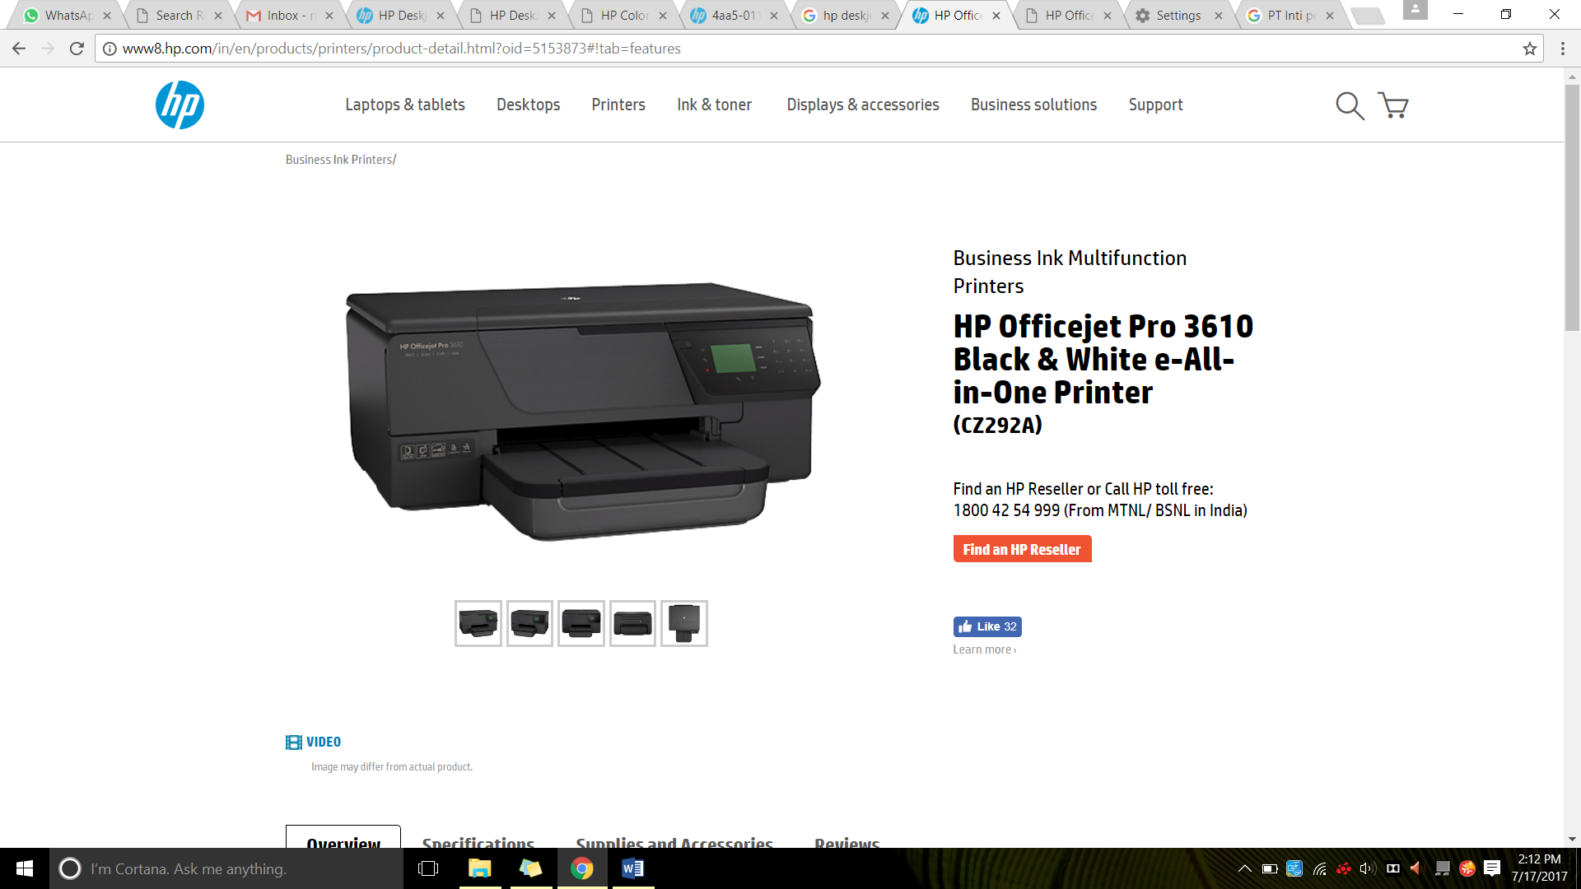

Figure - HP Pro 3610 Black and White E

|  |  |
| --- | --- |
| **Functions** | Print, Copy, Scan |
| **Multitasking supported** | Yes |
| **Minimum dimensions (W x D x H)** | 460 x 469 x 200 mm |
| **Maximum dimensions (W x D x H)** | 460 x 586 x 200 mm |
| **Weight** | 8.25 kg |
| **Power** | Input voltage 200 to 240 VAC, 50/60 Hz |
| **Power consumption** | 23 watts maximum (printing), 0.3 watts (Manual-Off), 3.03 watts (Standby), 1.45 watts (Sleep) |
| **Energy efficiency** | ENERGY STAR® qualified |
| **Operating temperature range** | 5 to 40°C |
| **Print speed black:** | ISO: Up to 19 ppm Draft: Up to 34 ppm |
| **Print technology** | HP Thermal Inkjet |
| **Print quality (best)** | Black: Up to 600 x 1200 dpi (on HP Brochure & Flyer Matte) |

* 1. Typical Station

All local station in Jakarta LRT consist of Telkom room, SCR and Traction Power. To manage all communication in and out to SCADA master and workstation this station need hight tech hardware which is;

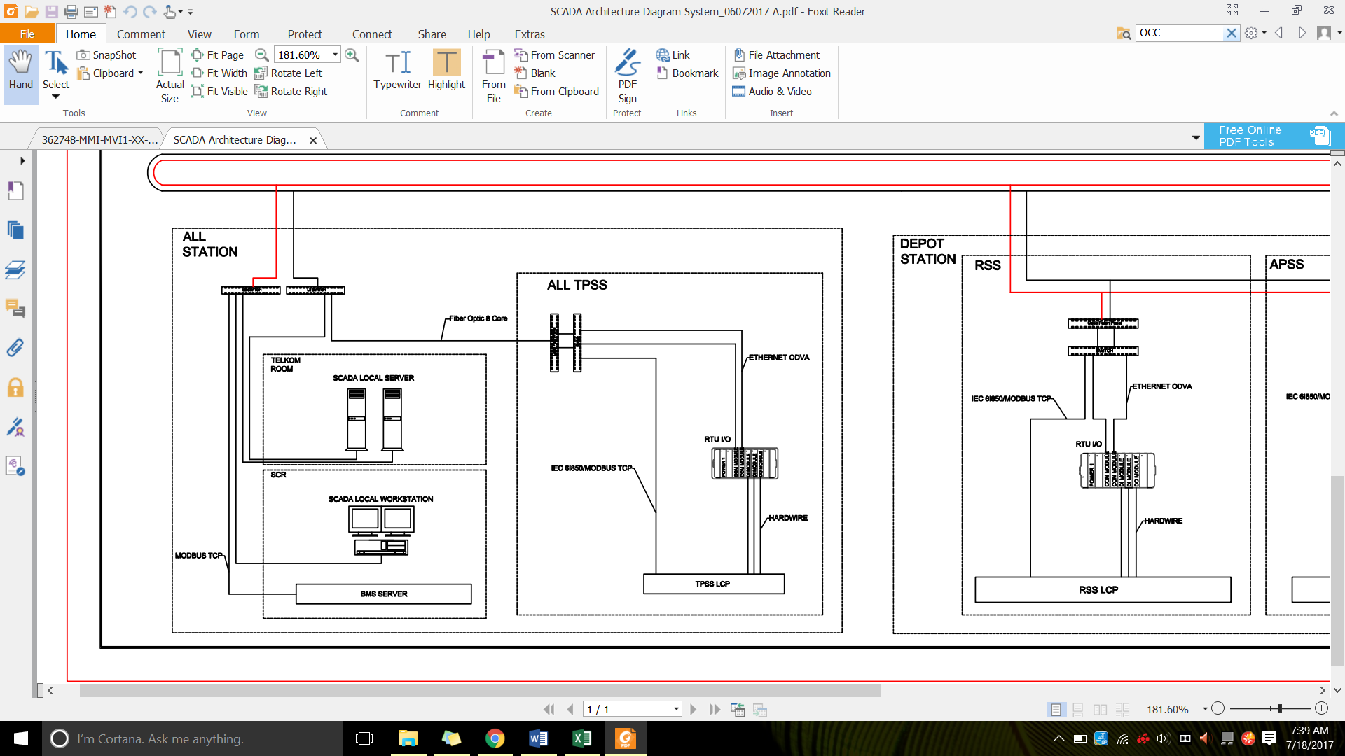

Figure - Station Arcitecture Diagram

* + 1. Local SCADA Server



Figure - HPE ProLiant DL 180 Gen 9

|  |  |
| --- | --- |
| **Operating System** | Windows Server 2016 x64 |
| **Processor** | Intel® Xeon® E5-2620v4, 2.1 GHz, 20MB Cache, 8 cores CPU |
| **Memory** | 32 GB (2x HPE 16GB 1Rx4 PC4-2400T-R Kit) |
| **Storage** | HP Smart Array P440ar/2G FIO Controller  2x HPE 300GB SAS 10k SFF SC HDD  2x HPE 600GB SAS 15K SFF SC HDD |
| **FBWC** | 2 GB DDR3-1,866 MHz, 72-bit wide bus at 14.9 GB/s on P440ar |
| **Battery** | HPE DL/ML/SL 96 W Smart Storage Battery optional |
| **HPE SmartDrives** | 24 + 2 SFF/12 + 3 LFF max, HDD/SSD, M.2 enabled and optional 6 NVMe PCIe SSD support |
| **Networking** | HP Embedded 1Gb Ethernet 4-port 331i Adapter |
| **VGA/serial/USB/SD ports** | Front VGA opt, rear VGA, and serial standard, 5 USB 3.0, 2 USB 2.0 optional, Dual microSD optional |
| **Power and cooling** | HPE 900W Standard AC 240VDC Redundant Power Supply Kit |
| **Industry compliance** | ASHRAE A3 and A4,6 lower idle power, and ENERGY STAR |
| **Form factor/Chassis depth** | Rack (2U), 26.75" (SFF) |
| **Serviceability—easy install rails** | Standard |
| **Operating Environment** | Operating temperature: 10 to 35°C  Operating humidity: 8 to 90% RH |
| **Warranty** | Protected by HP Services, including a 3 years parts, 3 years labor, and 3 years onsite service (3/3/3) standard limited warranty. Certain restrictions |

* + 1. Local SCADA PC



Figure - HP Z440 Workstation

|  |  |
| --- | --- |
| **Operating System** | Windows 10 Pro 64 |
| **Processor** | Intel® Xeon® E5-1603 v4 2.80GHz 10MB 2133 4Core CPU |
| **Memory** | 8GB DDR4-2400 (1x8GB) Registered RAM |
| **Storage** | 1TB 7200 RPM SATA |
| **VGA** | NVIDIA Quadro M2000 4GB 4xDP |
| **Networking** | Integrated Intel® I218LM PCIe GbE |
| **Ports and Connectors** | Front: 4 USB 3.0; 1 microphone; 1 headset  Back: 4 USB 3.0; 2 USB 2.0; 2 PS/2; 1 RJ-45; 1 audio line in; 1 audio line out  Internal: 1 USB 2.0; 1 USB 3.0 |
| **Power** | 700 W 90% efficient chasis |
| **Dimensions (W x D x H)** | 6.65 x 17.5 x 17 in / 16.9 x 44.5 x 43.2 cm |
| **Weight** | 24.3 lb / 11 kg |
| **Warranty** | Protected by HP Services, including a 3 years parts, 3 years labor, and 3 years onsite service (3/3/3) standard limited warranty. Certain restrictions |

* + 1. Workstation Monitor

Large 24-inch diagonal screen, with its wide range of viewing angles, full HD resolution and 5M:1 dynamic contrast ratio, seamless multi-monitor set-up with this bezel-less display.



Figure - HP N240 24-inch

|  |  |
| --- | --- |
| **Display Type** | IPS /LED backlight |
| **Panel Active Area** | 52.7 x 29.64 cm |
| **Display Size (diagonal)** | 60.45 cm (23.8") |
| **Viewing angle** | 178° horizontal, 178° vertical |
| **Brightness** | 250 cd/m² |
| **Contrast Ratio** | 1000:1 static, 5000000:1 dynamic |
| **Response Ratio** | 5 ms gray to gray |
| **Aspect Ratio** | 16:9 |
| **Native Resolution** | 1920 x 1080 (Full HD) @60 Hz |
| **Color Support** | Up to 16.7 million colors with the use of FRC technology |
| **Input Signal** | VGA, HDMI with HDCP support |
| **Input Power** | Input voltage: 100 to 240 VAC |
| **Power Consumption** | 15 W (maximum), 14 W (typical), 0.5 W (standby); 20 W (maximum), 18 W (typical), 0.5 W (standby) |
| **Dimensions** | 53.9 (W) x 15.2 (D) x 40.2 cm (H) with stand |
| **Total weight** | 3.4 kg with stand |
| **Ergonomic Features** | Tilt: -5 to +220 |
| **Energy efficiency** | ENERGY STAR® certified |
| **Operating Environment** | Operating temperature: 5 to 35°C  Operating humidity: 20 to 80% RH |
| **Environmental** | Arsenic-free display glass  Mercury-free display backlights  Low halogen |
| **What's in the box** | Monitor; External power supply; VGA cable; CD (includes user guide, warranty, drivers); HP Display Assistant |
| **Warranty** | Protected by HP, including a 3 year standard limited warranty. |

* 1. Schematic Drawing for SCADA

Please add here and attahed relevant drawing in Appendix

* 1. Installation Drawing for SCADA

Please add here and attached the relevant drawing in Appendix

# Software Functionality

## Zenon Product Family

As [automation](mk:@MSITStore:C:\Program%20Files%20(x86)\COPA-DATA\zenon%207.60%20SP0\Help\english\main.chm::/29612.htm#o168846) software for HMI, [SCADA](mk:@MSITStore:C:\Program%20Files%20(x86)\COPA-DATA\zenon%207.60%20SP0\Help\english\main.chm::/29648.htm#o168781) and reporting zenon provides a plethora of integrated functions for engineering and Runtime platform-independent.

Zenon has been used for over 25 years by many companies worldwide and in various industries. Zenon is firmly positioned in automation, particularly in the Automotive, Railway, Food & Beverage, Energy and Pharmaceutical industries.

With zenon function is:

* Create, distribute, edit and execute automation projects
* use integrated Soft-SPS zenon Logic
* Collect and evaluate [equipment](mk:@MSITStore:C:\Program%20Files%20(x86)\COPA-DATA\zenon%207.60%20SP0\Help\english\main.chm::/29620.htm#o168856)-spanning data from a plethora of sources

HMI/SCADA software from zenon i.e. the energy edition, by COPA-DATA is used for developing automation software for HMI in this project.

Zenon Energy Edition (EE) is used for this project, for both server and client. Zenon Energy Edition is the industry specific SCADA solution from COPA-DATA especially for power plant automation and substation automation, grid control technology and wind park management.

The drivers available in Zenon guarantee adherence to international standards such as IEC 61850/ EC 61400-25, IEC 60870 and DNP3. Furthermore, COPA-DATA is SIL 2 certified, thus enabling the implementation of zenon for process visualization and control in safety-critical applications.

Zenon security features including:

* IEC 61850 authentication
* DNP 3 secure authentication v2 and v5
* Encrypted network communication
* Data encryption with password and hash encryption
* Certified for Windows 10 – supporting all its sophisticated security features
* Active Directory
* No data stored in plain text
* Signed files
* Password protected SQL database access
* Each action can be locked/attributed to user rights
* Change history logging
* Chronological Event List (CEL) logging security incidents
* For NERC/CIP we provide information and documentation for parts CIP-002 through CIP-009
* Webserver offers HTTP Tunneling
* Webserver available solely for monitoring without operational functions

With its native drivers and communication protocols, zenon Energy Edition is perfectly suited for all communication tasks, whether with various IEDs or to remote systems. Zenon Energy Edition drivers and protocols including:

* IEC 61850 Client/Server and GOOSE
* TÜV SÜD certificate for IEC 61850 Edition 2
* IEC 61400-25
* IEC 60870-5 (101/103/104)
* DNP3
* IEC 62056-21
* OPC UA
* Modbus
* IEEE C37.118 (Synchrophasor)
* IEC 61850-90-5
* Slave/Server Side with the zenon Process Gateway for ICCP/ TASE.2/ IEC 60870-6, IEC 60870-5, DNP3, OPC UA, Modbus
* Integrated SCL Editor for IEC 61850 documents

## Zenon Editor

Zenon consists of two main components; Editor and Runtime. Projects are created in the Editor, operation and monitoring is done in the Runtime.

Zenon Editor´s user interface consists of different areas:

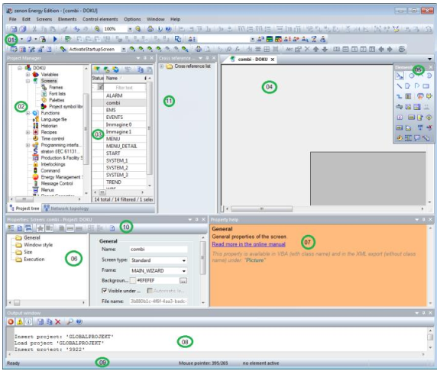

Figure – Zenon Editor Interface

| Element | Contents |
| --- | --- |
| 01 - Toolbars: | A collection of [Toolbars](mk:@MSITStore:C:\Program%20Files%20(x86)\COPA-DATA\zenon%207.60%20SP0\Help\english\main.chm::/138937.htm) for the Editor and its modules. They are available for:   * [Dockable](mk:@MSITStore:C:\Program%20Files%20(x86)\COPA-DATA\zenon%207.60%20SP0\Help\english\main.chm::/138938.htm) windows * [Alignment](mk:@MSITStore:C:\Program%20Files%20(x86)\COPA-DATA\zenon%207.60%20SP0\Help\english\main.chm::/138939.htm) * [Screens](mk:@MSITStore:C:\Program%20Files%20(x86)\COPA-DATA\zenon%207.60%20SP0\Help\english\main.chm::/138940.htm) / [Symbols](mk:@MSITStore:C:\Program%20Files%20(x86)\COPA-DATA\zenon%207.60%20SP0\Help\english\main.chm::/138941.htm) * [Editor profiles](mk:@MSITStore:C:\Program%20Files%20(x86)\COPA-DATA\zenon%207.60%20SP0\Help\english\main.chm::/138942.htm) * [Elements](mk:@MSITStore:C:\Program%20Files%20(x86)\COPA-DATA\zenon%207.60%20SP0\Help\english\main.chm::/138943.htm) * [Menu bar](mk:@MSITStore:C:\Program%20Files%20(x86)\COPA-DATA\zenon%207.60%20SP0\Help\english\main.chm::/138941.htm) * [Production & Facility Scheduler](mk:@MSITStore:C:\Program%20Files%20(x86)\COPA-DATA\zenon%207.60%20SP0\Help\english\main.chm::/138944.htm) * [Remote Transport](mk:@MSITStore:C:\Program%20Files%20(x86)\COPA-DATA\zenon%207.60%20SP0\Help\english\main.chm::/138945.htm) * [Report Generator](mk:@MSITStore:C:\Program%20Files%20(x86)\COPA-DATA\zenon%207.60%20SP0\Help\english\main.chm::/138946.htm) * [Runtime Files](mk:@MSITStore:C:\Program%20Files%20(x86)\COPA-DATA\zenon%207.60%20SP0\Help\english\main.chm::/138947.htm) * [Visibility levels](mk:@MSITStore:C:\Program%20Files%20(x86)\COPA-DATA\zenon%207.60%20SP0\Help\english\main.chm::/138948.htm) * [VBA macros](mk:@MSITStore:C:\Program%20Files%20(x86)\COPA-DATA\zenon%207.60%20SP0\Help\english\main.chm::/138949.htm) |
| 02 - Project Manager: | Tree view of the Project Manager. |
| 03 - Detail view of the Project Manager: | Details for the module selected in the Project Manager. |
| 04 - Main [window](mk:@MSITStore:C:\Program%20Files%20(x86)\COPA-DATA\zenon%207.60%20SP0\Help\english\main.chm::/29658.htm#o168899): | Main work space; here documents such as screens or reports are displayed. |
| 05 - [Toolbar](mk:@MSITStore:C:\Program%20Files%20(x86)\COPA-DATA\zenon%207.60%20SP0\Help\english\main.chm::/29652.htm#o168901) elements: | Toolbar for [screen](mk:@MSITStore:C:\Program%20Files%20(x86)\COPA-DATA\zenon%207.60%20SP0\Help\english\main.chm::/29648.htm#o168516) elements - vector elements and dynamic elements. |
| 06 – Properties | Displays the properties of a selected object. Three modes are available and can be selected from the [Properties toolbar](mk:@MSITStore:C:\Program%20Files%20(x86)\COPA-DATA\zenon%207.60%20SP0\Help\english\main.chm::/138951.htm). |
| 07 - Properties help: | Displays short help messages for properties of screens, variables, functions and other elements which can be engineered. |
| 08 - Output window | Messages are displayed here if projects are compiled and sent to Runtime. |
| 09 - Status bar: | Shows status information for Editor readiness and screens. |
| 10 - Toolbar properties: | Defines display and sorting options of the properties, shows [Properties help](mk:@MSITStore:C:\Program%20Files%20(x86)\COPA-DATA\zenon%207.60%20SP0\Help\english\main.chm::/139020.htm). |
| 11 - Cross-reference list: |  |

Table – Zenon Editor Interface Element

Please add graphical possibilities table here

## Zenon Runtime

Zenon Runtime is software that supports graphic display possibilities for HMI/[SCADA](mk:@MSITStore:C:\Program%20Files%20(x86)\COPA-DATA\zenon%207.60%20SP0\Help\english\main.chm::/29648.htm#o168781) projects. Zenon Runtime offers:

* Process display
* Archiving of data such as messages and process values
* Integrated alarm message list
* Recipes
* Multi-Touch, etc.

The minimum requirements for running zenon Runtime are listed in the following table:

| Element | Contents | Recommended |
| --- | --- | --- |
| CPU | Single core with SSE2 support | Quad Core |
| RAM memory | Windows 7/8: from 512 MB | Windows 7/8: 4096 MB |
| Harddisk | 2 GB free space for the Runtime-installation plus additional space for the projects |  |
| Monitor resolution | VGA with 640 x 480 pixels |  |
| Graphics adapter | 64 MB dedicated memory. Cards with shared memory can lead to performance loss. |  |
| Input devices | Keyboard and/or mouse. Operation via touchscreen is also possible. |  |
| USB interface (optional) | * For installation. Installation also possible via network or other storage media. * For dongle. Network dongle also available. |  |
| Network connection (optional) | 64 kBits/s for standard Client/Server projects.  100 Mbit/s full duplex for redundant operation. | 100 Mbits/s full duplex for standard Client/Server projects |
| Interfaces (optional) | The necessary interfaces depend on the requirements of the PLC and/or the bus connection, for example serial RS232 or RS422/485 interfaces, ISA/PCI slots, etc. |  |

Table – Zenon Runtime Minimum Requirements

Zenon Runtime communicates with all possible controllers using drivers. The drivers support a number of protocols, some of them is listed below:

* Allen Bradley DF1 and ODVA driver
* BACnet
* DNP3 driver
* IEC 60870, 61400, 61499, 61850 (Client and Server), 62056 and 60870 driver
* Modbus Master and Slave protocol
* Modbus RTU and Open Modbus TCP
* OPC Client V2-0 and OPC UA Client driver
* SNMP driver, etc.

## Zenon HMI Feature

Zenon Energy Edition include several features which useful for development of HMI SCADA in this project, that is:

* Historian
* Chronological Event List (CEL)
* Automatic Line Coloring (ALC)
* Alarm administration
* User administration
* Logic Control - Straton

### **Historian**

In zenon, the Historian takes on the saving of process data as well as the export of the archived data. The data is thus available for subsequent processing and evaluation - even outside of zenon.

Historian in zenon including some features like:

* Data logging: cyclic, event-triggered, on change
* Cascaded data aggregation (aggregated archives)
* Event recording
* RDA archiving
* SQL evacuation
* User-defined start/stop of recording
* Function execution when starting and closing the archive
* Automatic data evacuation
* Automatic creation of substitute archives
* Data export via a function (to XML for example)
* Manual revision of archive data

Data from archiving can be reused in zenon for reporting purposes:

* Report Generator.

The Report Generator works on a cell-orientated basis. Each of these cells can be assigned certain formats and functions. A report is configured as its own screen as a Report Generator screen. The data is calculated, output and displayed using pre-defined report functions. These can be entered into the respective cells using a dialog or manually. To be able to display reports in Runtime, they must be configured in the Editor.

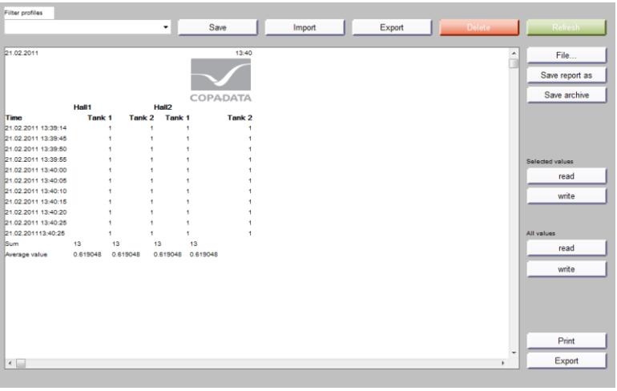

Figure – Zenon Report Generator Feature

* Report Viewer

The Report Viewer also allows archive data to be prepared for the user. However, in contrast to the Report Generator, these cannot longer be modified. For this, the Report Viewer offers extensive graphic possibilities for display, such as diagrams. In addition, two time ranges for incoming analyses can be compared with one another.

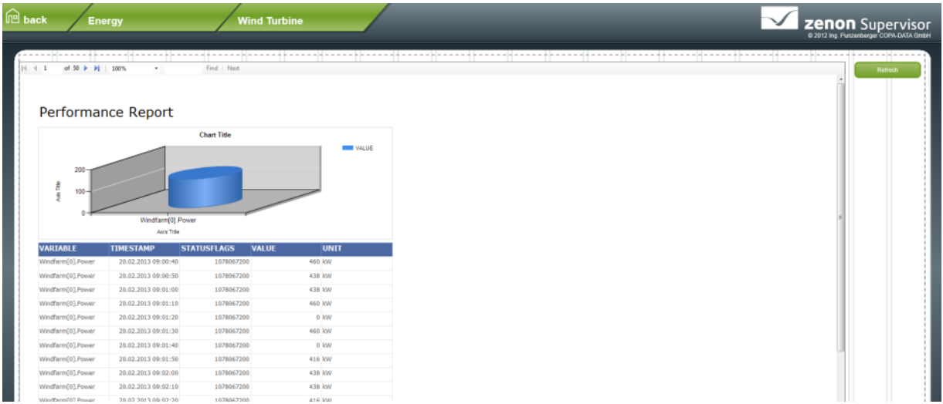

Figure – Zenon Report Viewer Feature

To be able to create reports using the Report Viewer, software from third-party providers will also be required. Microsoft Report Designer is therefore also installed when zenon is installed. This opens as soon as you create a new report. There is a separate screen type for display in Runtime.

* Extended Trend

Extended Trend which requires a license, provides online values and archive values from variables as curves. In contrast to the trend dynamic element, it is possible to zoom, browse, query and scale online values and values from archives. As with the Report Generator and the Report Viewer, there is also a separate screen type for Extended Trend.

### **Chronological Event List**

In the Chronological Event List (CEL) system events and user inputs can be logged, e.g.:

* Alarm acknowledgement
* Delete alarms
* Set value
* Send recipes
* Change recipe
* Archive data
* User action
* Network action

A Chronological Event List screen makes it possible to log and display system events and user operations in the Runtime. Which entries are displayed is defined via the engineering. The display can be changed by filters in the engineering and in the Runtime. Functions make it possible to export and print the displayed events.

CEL Exports can be carried out in different formats. Which columns are exported, and how, depends on the source (AML/CEL) and the export format is listed below:

* CSV
* dBase
* SQL
* XML

### **Automatic Line Coloring (ALC)**

Automatic Line Coloring (ALC) makes it possible to color lines depending on the process status. The combined element is used as the process element. Automatic line coloring allows easy automatic dynamizing of tubes in technology (for media) as well as in the topological networks (for electricity).

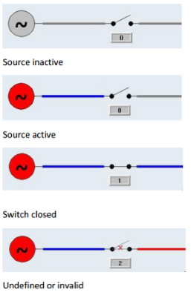

Figure – Zenon ALC Example

### **Alarm Administration**

Alarm administration informs faults that occur such as limit values being exceeded. It comprises:

1. Alarm status line

Information line that is always shown in the foreground in Runtime and contains, depending on the configuration, the most recent or oldest unacknowledged alarms.

1. Alarm Message List (AML)

Administers the alarms in a list in Runtime. The AML:

* Displays alarms and their causes in an unfiltered or filtered list
* Enables localization of the cause of the alarm
* Enables acknowledgment of alarms
* Enables deletion of alarms.
* Enables printing and saving of alarms

Alarms can be exported in different formats:

* dBase
* CSV
* XML
* SQL

### **User administration**

Zenon supports user administration for the Editor and for online operation Runtime. The concept of zenon user administration assumes that different users have different operating rights (authorization levels and function authorizations). Administrators also have different rights, but have additional administrative rights, such as the administration of users. Users can be administered via zenon and the Windows Active Directory.

Each user can be assigned several different authorizations. A maximum of 128 (0 to 127) authorizations can be configured. Users can be assigned to the individual authorization levels and the attendant project-specific password design in relation to this can be created completely freely. Each user can have any level allocated. Thus e.g. user 1 can have levels 0, 1, 5 and 6 assigned and user 2 can have levels 0, 1, 6, 8 and 10 assigned. Authorizations can only be issued if the administrator has those rights himself.

The user is logged in in Runtime using the login function and a login screen. If the user is to be logged in automatically based on an event (e.g. position of a key known to the system). The SCADA workstations shall display the name of the operator who is currently logged in. The Login without password function is used. This function is projected with a limit value or a Rema of the variable in the variable management, respectively. With multi-project administration, users can automatically be logged in to subprojects with automatic login.

If during a defined period of time there is no operation, an automatic time-triggered logout can be engineered. Users can log off from the system at any time using the logout function. The user SYSTEM is thus logged in.

User access rights can be determined by use of a configuration table. In doing so, the following applies:

* You must be logged in as an administrator.
* You can create new users.
* You can edit users.zenon login and user administration in Runtime
* You can delete users.
* You can only issue function authorizations that you have yourself directly or as a member of a user group.

To administer users in lists:

1. Log in as an administrator.

2. Create a user list screen.

3. Configure the desired settings.

* Clicking on New opens an edit user screen. This must be linked for screen switching.
* Clicking on Edit opens an edit user screen. This must be linked for screen switching.

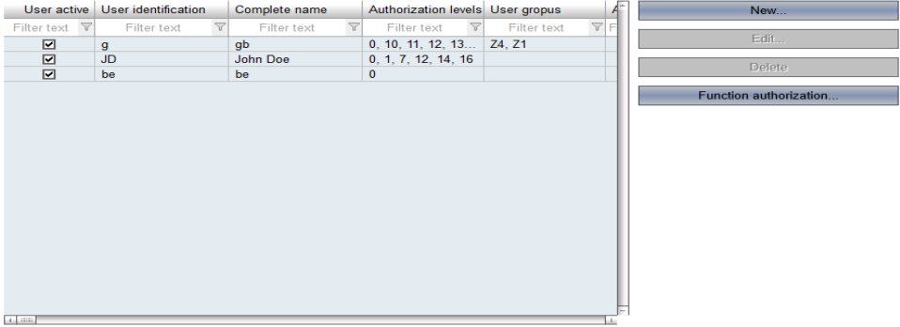

Figure - User administer configuration table

# Supplementary Functions

## Redundancy

Redundancy in zenon ensures that processes are not interrupted even in the event of a failure of the Primary Server and that no data is lost. Seamless redundancy in zenon means that the time period between the failure of the Primary Server and detection of the failure is protected from data loss. This is implemented as follows:

1. The Standby Server buffers all data.
2. The Standby Server detects the failure of the Primary Server and automatically takes on the complete functionality thereof.
3. The standby server adds the data from the buffer to the corresponding modules (AML, CEL, archives).

Project changes need only be entered on the Primary Server; the standby server and the connected clients automatically synchronize online data. This ensures that the project status is the same on all computers.

There are two kind of redundancy systems in zenon, that is:

1. Software redundancy

The primary server communicates with the controller on a two-way basis; the standby server is read only

1. Hardware redundancy

Both servers communicate on a two-way basis with the respective connected controller. This kind of redndancy is usually applied in conjunction with controllers connected in series.

For this project, software redundancy system is used.

In normal operation, both computers communicate with the controller; in doing so:

* The Primary Server communicates with the controller in two directions (read and write)
* The Standby communicates with the controller as read only
* Both computers keep the controller’s data current and synchronous database

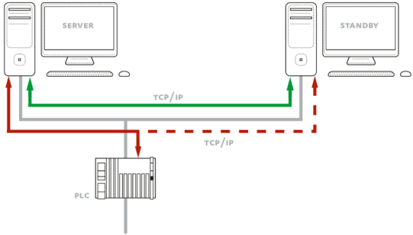

Figure – Zenon Software Redundancy Example

In the event of a failure of the Primary Server:

* The Standby Server becomes the new Primary Server
* The Seamless redundancy ensures that all data is complete without omissions, including data from the time between the failure and the switch
* The new Primary Server communicates with the PLC both ways

For software redundancy type, there are three different redundancy modes available. The distribution of roles (Primary Server or Standby Server) during operation and after the re-availability of a server that failed beforehand depends on the selected redundancy mode.

* Dominant

1. The Primary Server fails.
2. The original Primary Server goes online again. In doing so:

a) It connects to the current Primary Server

b) It synchronizes all data

c) It becomes the Primary Server itself again

1. The original Standby Server becomes the Standby Server again.
2. All Clients connect to the new Primary Server.

* Non-dominant

1. The Primary Server fails.
2. The original Primary Server goes online again. In doing so:

a) It connects to the current Primary Server

b) It synchronizes all data

c) It becomes the Standby Server itself

1. The current Primary Server remains the Priimary Server.
2. All Clients retain the connection to this.

* Rated

With rated redundancy, the roles of Primary Server and Standby Server are given on the basis of an evaluation matrix. In doing so:

1. Both computers each carry out a rating calculation on the basis of configured rating criteria.
2. The computer that has the higher rating becomes the Primary Server
3. No change of roles is carried out if both computers have the same rating
4. Alarms and CEL entries are written by the Primary Server
5. The clients connect to the Primary Server

In this project, Dominant redundancy mode is used. Main server will act as Primary Server, and whenever Main server fails, Backup server will replace Main server as Primary Server. When Main server back to normal again, it will be act as Primary Server again, not Backup server.

## SIL 2 Safety Application

There are plants that need to correspond to particular safety standards. The IEC 61508 standard helps to ensure safety with the Safety Integrity Levels (SIL). COPA-DATA is SIL 2 certified, thus enabling the implementation of zenon for process visualization and control in safety-critical applications.

The Safety Integrity Levels (SIL) are defined in the IEC 61508 standard. The SILs relate to electrical, electronic or programmable electronic systems (E/E/PE systems), that could cause damage. Companies that operate such safety critical equipment can make standardized safety precautions with the help of SIL certification and minimize the danger of malfunctions. The safety levels range from 1 to 4 and denote how signifcant any damage to be expected is and the probability with which this may occur. The greater the damage that can arise and the greater the risk that this damage may occur, the higher the required level of safety.

The level of the safety risk and the attendant SIL that is required is established using analyses of scenarios. The basis of this analysis is an estimation of the areas in which damage can occur in a company. Based on this, a calculation is made to determine how probable this damage is and how serious the consequences of this are if it occurs.

Software planning and development according to IEC 61508-3 forces manufacturers to clearly defne their processes and procedures. Work steps need to be precisely documented and checked. The principle of dual control applies to every step of the process. COPADATA is certifed to SIL 2 in accordance with the requirements of the IEC 61508 standard.

Zenon can be implemented in safety-critical applications for process visualization and control. Numerous safety relevant functionalities support our customers in developing highly reliable applications. Furthermore, the TÜV Süd certifcation offers the necessary framework for a safety conform implementation.

## Signalling Driver

The requirement of the project is to interface with signalling system to get the relevant information for the train timetable, alarms and send some information of 3rd rails energisation to the signalling system. The signalling system WPC provided the protocol document for this interface. Inline with this, the special driver in developed for the signalling protocol interface.

This driver consists some functions such as establishing connection, making communication for data exchange, auto reconnection, closing connection and sending heartbeat.

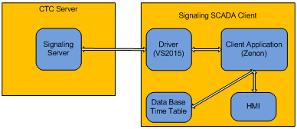

Figure – Signalling Driver Block Diagram

The driver will start communication with CTC server using TCP/IP Client-Server method through the port server. The CTC server will provide all of signaling data includes the data which are needed by SCADA client. The functionality provided by the driver will be embedded into the Client Application for the user or operator to be able to use the function in HMI.

There are many types of data transferred between the CTC Server and the SCADA Client, that is:

* 3rd rail status (SCADA to CTC Server)
* Total schedule information
* Today’s running schedule ID
* Modified schedule
* Train position
* Alarm

One of data types is data schedule of train. The data schedule of train operation is sent to SCADA Client and saved in certain data base of time table. Every change of schedule must be sent to SCADA Client through the driver. So the Client Application always get updated schedule. It’s important to be used in HMI functions.

The driver is very important thing here. If the driver is not working well so the client application can’t get update data from CTC server and send 3rd rail data. The driver must be designed robust and safe. Data base is needed to save time table or schedule of train temporary until newer time table comes. When communication is lost, the client application still can use time table in data base for meanwhile.

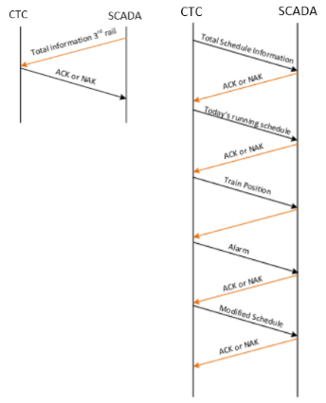

Figure – CTC – SCADA Data Flow Control

With the driver, the client application can get signaling data (such as train schedules, train locations, alarms) and also send back 3rd status to CTC server. The CTC server and the client application communicate periodically in 3 seconds. This communication process is handled by the driver. The driver also handles about flow control of communication between server and client such as establishing connection, making communication for data exchanges, auto reconnection, closing connection and sending heartbeat must be handled by the driver.

Please add the signalling driver architecture here.

For further detais for the on the protocol between Signalling and SCADA please refer to ICD – XXX – XXXX

## ONVIF Driver

The requirement of the tender is for SCADA to interface to CCTV system. This will be done base on open protocol i.e. ONVIF. Via this protocol only the live view (which is relavant to operation) for the CCTV will be shown in the SCADA system. All playback and other CCTV control be done within the CCTV workstation. ONVIF has various profiles witihon the standard. Profile-S will be implemented for this interface. Profile-S driver will be added and implemented in Zenon to execute this interface.

ONVIF (Open Network Video Interface Forum) is a global and open industry forum with the goal of facilitating the development and use of a global open standard for the interface of physical IP-based security products, for example to create a standard for how IP products within video surveillance and other physical security areas can communicate with each other.

Communication in the Onvif specification using web service technology. Web service is a standardization method for communication between applications using XML, SOAP, and WSDL standards. XML is used as description syntax, SOAP is used to transfer messages, and WSDL is used to describe services.



Figure – Web Service WSDL System Overview

Building on ONVIF Specifications, ONVIF Profiles are collections specifications that guarantee the interoperability of specific features between conformant devices. An ONVIF profile has a fixed set of functionalities that must be supported by a device or client. It ensures that a client that conforms to Profile S, for example, will work with a device that also conforms to Profile S. Clients and devices can support more than one ONVIF profile; for instance, a network camera with local storage can conform to both Profile S and G.

Conformance to profiles is the only way that ensures compatibility between ONVIF conformant products; therefore, only registered products with conformance to a profile are considered to be ONVIF conformant.

There are several ONVIF profiles depend of their functionalities, that is:

* Profile S - Addresses common functionalities of IP video systems, such as video and audio streaming, PTZ (Pan-Tilt-Zoom) control and relay output, video configuration and multicast.
* Profile C - Addresses common functionalities of IP access control systems, such as site information and configuration, event and alarm management, door access control.
* Profile G - Addresses edge storage and retrieval such as configure, request and control recording, receive audio and metadata stream.
* Profile Q - Addresses discovery, configuration and control of conformant devices, as well as advanced security functionality for example the management of TLS certificates and keys.
* Profile A - Addresses for broader access control configuration such as granting/revoking credentials, creating schedules, and assigning access rules
* Profile T (Release Candidate) - Addresses for advanced video streaming such as H.264 and H.265 video comporession, HTTPS for secure streaming, imaging settings, alarm events, digital input and relay output, bidirectional audio

For this project, ONVIF Profile S is used in SCADA system, in order access and control PTZ camera to improving safety in remote or hazardous area.

An ONVIF device compliant to the Profile S is an ONVIF device that sends video data over an IP network to a client. The Profile S also includes support for PTZ, audio and metadata streaming, and relay outputs if those features are present on the device. For example, a device compliant to the Profile S may be an IP network camera or an encoder device.

An ONVIF client compliant to the Profile S is an ONVIF client that can configure, request, and control streaming of video data over an IP network from an ONVIF device compliant to the Profile S. The Profile S also includes support for control of PTZ, receiving audio and metadata stream, and relay outputs if those features are supported by the client.

An ONVIF profile is described by a fixed set of functionalities through a number of services that are provided by the ONVIF standard. A number of services and functionalities are mandatory for each type of ONVIF profile. An ONVIF device and client may support any combination of profiles and other optional services and functionalities.

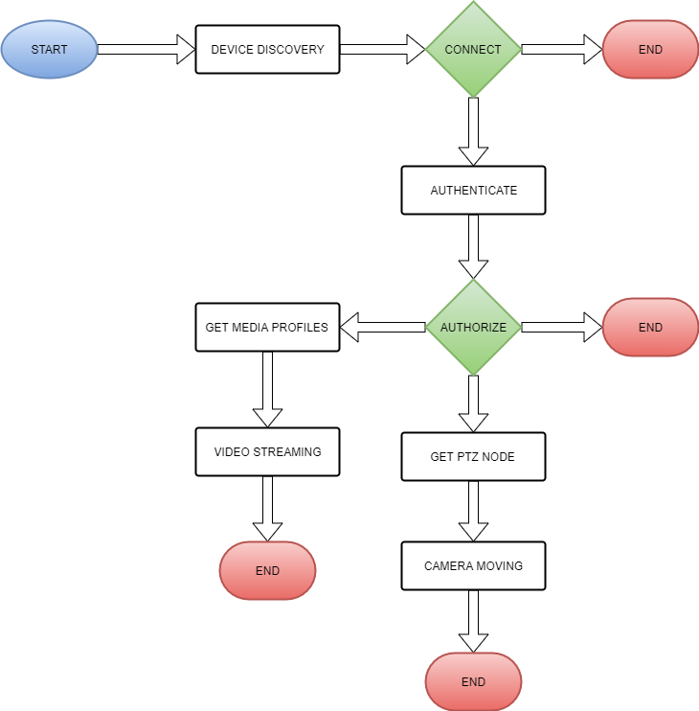

Figure – ONVIF Profile S Flow Control

Figure above shows ONVIF Profile S functionality for controlling PTZ. Two main functionalities for PTZ which ONVIF Profile S done in this project is video streaming and PTZ camera control movement. Device discovery and authentication must be done first, so the driver can access all services in the devices, including video streaming and camera control. Video streaming will be showed via monitor in SCR room in each station (local). Monitor in OCC room also can show video streaming from all station by selection.

Please add the ONVIF Driver architecture

## PA/PIS Driver……is missing

# Project Specific Configuration

* 1. General

For the Jakarta LRT operational purposes, SCADA System will be comprise of the following major equipment, that are:

* SCADA OCC Server
* SCADA OCC Workstation
* SCADA Local Server
* SCADA Local Workstation
* SCADA RTU (Remote Terminal Unit)

SCADA Server will be responsible to interface with various of other subsystem to form data exchange for monitoring and controlling purposes. Whereas SCADA workstations both in OCC and local will be the client of SCADA Server respectfully and will also act as an operator interface. SCADA RTU will be used as interface with the local system at each station or substation.

SCADA system will be connected and interface with the following subsystem:

* Traction Power Substation
  + Interface via RTU I/O, IEC 61850 for protection relay and Modbus for Power Meter
  + Monitoring and Control
* Building Management System
  + Interface via Modbus Protocol
  + Monitoring and Control
* Signalling System
  + Interface via Signalling Driver developed.
  + Train descrier data from signalling for Automation trigger for PA and PIDS
  + 3rd Rail power states send to signalling via the signalling driver
  + No Signalling control from SCADA
* Public Announcement (PA)
  + Interface via Open Acces SDK driver developed
  + Monitoring and Control
* Public Information Display (PID)
  + Interface via Open Acces SDK driver developed
  + Monitoring and Control
* Passanger Help point (PHP)
  + Interface via Open Acces SDK driver developed
  + Monitoring and Control
* CCTV System
  + Interface via ONVIF driver developed
  + Monitoring and Control(PTZ Control only). Playback will be at CCTV workstation
* Access Management System (AMS)
  + Interface via XXX
  + Monitoring and Control ???
* Radio Tetra
  + Interface via XXX
  + Monitoring and Control ??
* Fiber Optic Transmission System
  + Interface via SNMP
  + Monitoring for status and alarm only
  + No Control
* Master Clock
  + Interface via SNMP
  + Monitoring for status and alarm only
  + No Control
* Wide Area Network (WAN)
  + Interface via SNMP
  + Monitoring for status and alarm only
  + No Control
* Automatic Fare Collection (AFC)
  + Interface via XXX
  + Monitoring and Control ??
* Platform Screed Door (PSD)
  + Interface via XXX
  + Monitoring and Control ??
  1. Control Philosophy and Hierarchy

On LRT Jakarta, SCADA System will be used to monitor and control various of system centralize at OCC. Interface between SCADA System and other system will be done on three ways, which are:

* SCADA Server to Another Server Connection at OCC
* SCADA Server to BMS Server at Local Station
* SCADA RTU to Other Controller or Equipment at Station

All this data will be gathered and coordinated by SCADA Server, and operated by operator through SCADA Workstation. SCADA System will have two types of workstation, one type will be used to control and monitor all station at OCC, and the other will be used and installed locally on each station.

* + 1. Control Console Permission

As mentioned above, SCADA System purpose is to centralize process monitoring and control of various system which connected to SCADA System. Usually, the system which connected to SCADA system also have their own local control and workstation that can be operated by operator. Not to mention that SCADA System also have two types of workstation, which will be installed at occ and locally at each station. So, clear definition of which workstation will have authority to send command control to the equipment is required.

To Solve the problem, Remote/Local Permissive mechanism will be introduced to determine which workstation that have authority to send command control. The Remote/Local mechanism can be shown on the following diagram.

Remote

Remote Permisive Command

Local Permisive Status

Remote Permisive Status

Local Permisive Command

Local

Figure - Remote/Local Permissive mechanism

From the diagram above we can see that each remote or local will have following bits:

* Permissive Command
* Permissive Status (from other side permissive command)

Permissive command is a permission for the particular workstation to be allowed to give command to the system. Value of Permissive command 1 means that the particular workstation is taken over the control command. Value of permissive command 0 means that the particular workstation is releasing the right to give command to the system. Permisive status is a status of the permissive command from the other side of workstation. For example, for remote and local workstation, the remote workstation will have following bit:

* Remote permissive command (used for remote workstation to take or release the permission to give control command).
* Local Permissive status (is status of local permissive command from local workstation)

And vice versa for local workstation bit authority command.

Before, for example, remote workstation is decided to take the right to give command control, remote workstation first need to check the status of local permissive status bit. If the value of local permissive status is 0, then remote workstation can procced the process to take the right for command control. And if the value of local permissive status is 1, then remote workstation will not be allowed to take the right for command control. And vice versa for local workstation.

This Authorization for control command right will be used between SCADA System workstation and Another system workstation. And also, between SCADA System OCC Workstation and SCADA System Local workstation.

Who has higher priority? Not explained. The the explanation more simpler. The simple logic diagam and table will be adequate.

* + 1. Operation Control Hirarchy

The Operation of SCADA System will consist of but shall not be limited to the following situation or condition, which are:

* Starting Up Situation
* Normal Operation Situation
* Emergency/Service Operation Situation
* Shuting down situation

#### **Starting Up Situation**

For Starting up, which system to be starting first between SCADA system and another system that connected to SCADA system is not important. So, any system can be starting up first. When SCADA System starting up for the first time, SCADA System will not take the right for command control. Instead, command control will be done locally through the local control system.

This way, All the system which will be connected to the SCADA System can be started independently from SCADA System. Each system than can do consistency testing through their own workstation. After finishing testing, each system will release command permissive from their own’s local workstation to be taken over by SCADA Workstation.

#### **Normal Operation Situation**

SCADA System will only use to operate for normal operation only. Under normal operation, all control to the system will be operated centralize and taken over by the SCADA OCC Workstation.

#### **Emergency Operation Situation**

When there is some equipment that needed to run in emergency or services, SCADA system will release the right for command control and will be taken over by correspond local workstation. Because operate under service or emergency will need for the operator and technician to be near the equipment being sevices or running under emergency mode. This way, local operator and technician will have full control of equipment being services, and also be able to organize safety procedure easier.

After the equipment able to run normally, the correspond local workstation will release their right for command control and will be taken over by SCADA System to be able to operate normally.

#### **Shutting down situation**

When there is some major failure that make the SCADA system shutting down, All correspond local workstation should be able to detect communication failure to the SCADA System, which in turn, will automatically release the right for command control. So, this way, correspond local workstation can take over for command control right.

As said earlier, the complete control philosophy can be described with a logic diagram and a table. Please consider

* + 1. OCC Operating Console – Monitor Concept

SCADA System will be equipped with SCADA OCC Worstation as SCADA OCC Operating Console. Through particular workstation, the SCADA operator will be able to monitor and control all system which connected to SCADA System at all station. SCADA OCC Workstation will be connected directly to SCADA Server to get and send data.

SCADA OCC Workstation will be equipped with four monitors. The individual function of each monitor can be described on the following:

* First monitor use as Overview of the System
* Second monitor use as Workspace to control and monitor
* Third monitor use as Alarm and CEL
* Fourth monitor use as CCTV Spot Monitor
  + 1. Local Operating Console – Monitor Concept

SCADA System will also be equipped with SCADA Local Workstation in order for SCADA operator to be able to operate SCADA System at local station. SCADA Local workstation will have limitation to only be able to monitor or control all system within correspond station. SCADA Local workstation will be equipped with two monitors, which are:

* First Monitor use as Overview of the System. In emergency situration it will be used for Alarm and CEL
* Second monitor use as Workspace for Control and Monitor

There will be no monitor that will be use as CCTV display at SCADA Local Workstation. Instead, a 3rd monitor will be fitted next to the 2 SCADA monitor which will be Local CCTV client workstation monitor working a CCTV spot monitor. This 3rd monitor can also then work for playback when required.

* + 1. Video Wall Display

SCADA System will equipped with video wall controller to interface with a video wall monitor. SCADA System will only display overview of the system that connected to SCADA System on video wall Display. So, the display will only represent of the important data of the system.

The video wall controller is planning to have up to 6 video connector interfaces (HDMI, VGA, etc.) to make connection with video wall display. The planning of 8 individual video connector are as follow:

* 2 video connectors use to display Traction Power Substation Overview
* 2 video connectors use to display building management system overview
* 2 video connectors use to display telecom and utility overview
  1. I/O List

The SCADA system provides and overview of the Rail Systme in OCC. It is interfaced to various system as described in chapter XXX above.

The I/O list is derived and consolidated via various protocol as shown in the table below

| No | Protocol | Subsystem | Remark |
| --- | --- | --- | --- |
| 1 | SNMP | PABX Server |  |
| AFC Server |  |
| Radio System Server |  |
| Backbone and Access Server |  |
| NTP Server |  |
| 2 | OPC UA | CCTV and Security Server |  |
| 3 | ModBus TCP | BMS RTU |  |
| APSS Protection Device | Assumption |
| 4 | ODVA | Allen Bradley TPSS RTU |  |
| 5 | Open Acces SDK | PA, PID, PHP Server |  |
| 6 | DAEATI Signalling Protocol | Signalling Server |  |
| 7 | IEC 61850 | TPSS Protection Relay | Assumption |

Table - SCADA IO List

The complete I/O list is depicted in document appendix B.

* 1. SCADA System Design and Functionality
     1. Archive

All Health status, data, and alarm from all system equipment that will be connected to SCADA System will be stored in the form of Archive in SCADA Server. The Archive will only store the data only if there is a data changing or if a value is passing of desired level of data.

The archive will store the information of but shall not be limited to the following:

* Time of data stored
* Text status of the data
* Measure unit use
* Value of the data
* Etc.

Following shown below the drawing example of the Archive in SCADA System



Table - storage the form of Archive in SCADA Server

* + 1. Alarm

When the alarm from a system that connected to SCADA System is arise, beside stored the data to the archive, SCADA System will also display the data on the alarm list to show the operator that there is an alarm to the system. SCADA System alarm list will grouped the alarm into three group

* Urgent Alarm – Assigned to important alarm.
* Alert Alarm - assigned to alarm which have lower priority
* Cleared - means that the alarm condition has been cleared.

Each alarm that will be displayed on the alarm list will have four states, which are :

* Active State - alarm is present and has not been acknowledged
* Acknowledged state - alarm is present and has been acknowledged
* Reset state - alarm has not been acknowledged and cleared.
* Cleared state – alarm has been acknowledged and cleared

When the alarm present and has not been acknowledged, the alarm list will display the particular alarm to be flashing. The data that will be show on the alarm list are as follows:

* Alarm State
* Alarm time received
* Alarm time cleared
* Alarm time acknowledged
* Variable name
* Value of the data
* Measurement unit
* Text status
* Etc.

Following show the example of SCADA System alarm list from Zenon alarm dialog template



Table - SCADA System alarm list display

* + 1. Screen Display Design

The following screen design is the concept of General HMI screen design. individual system screen designs are covered in the various system design and phosophy chapter below.

* BMS Main Screen (including telco)
* Power Main Screen
* CCTV Main Screen
* Alarm List Main Screen
  + - 1. Home Screen Display

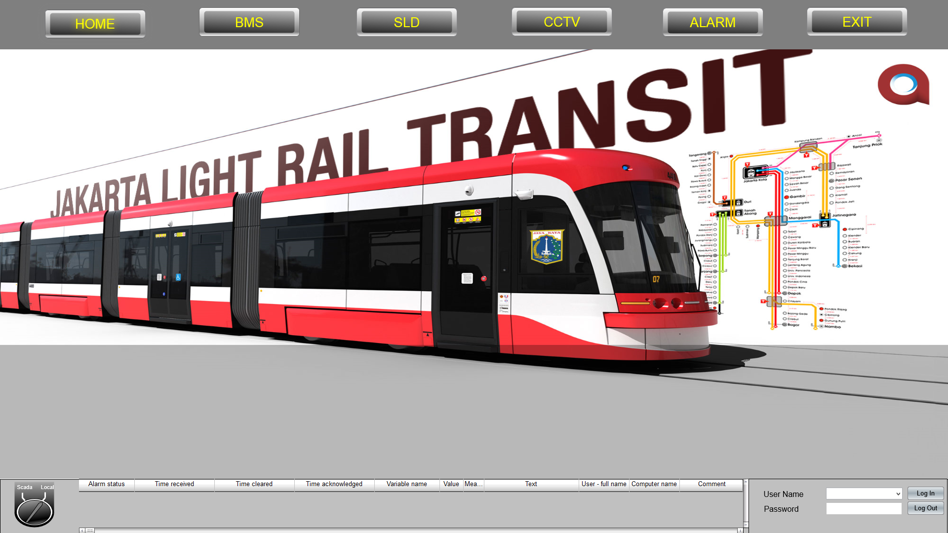This screen will be viewed when the program is launched. The screen shot is shown below. From this screen we can choose to enter specicific subsystem mentioned above.

Figure - Home Screen Display

BMS screen will overview the status of all BMS equipment. This screen also acts as BMS main view.

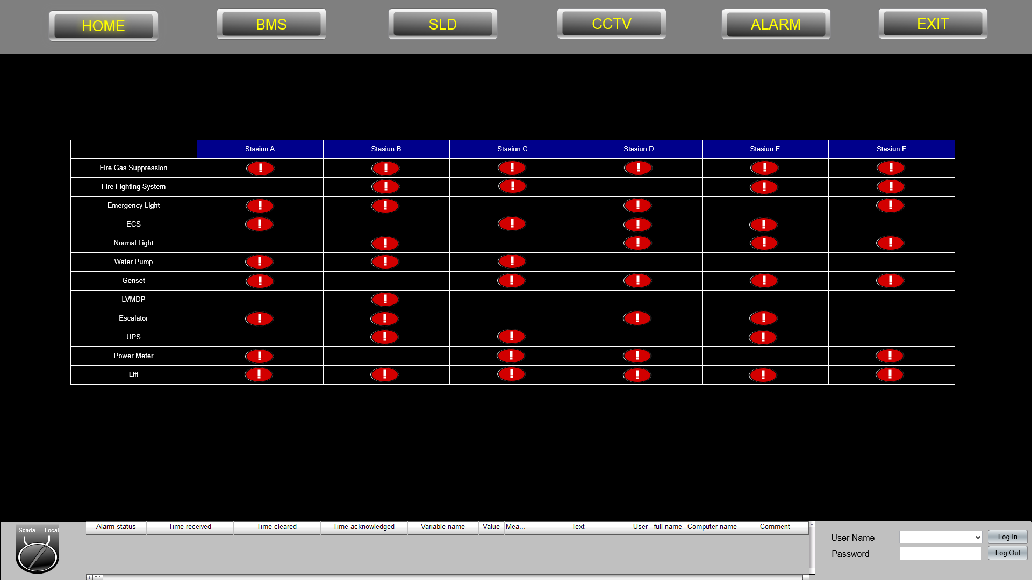

Figure - BMS Status Display

* + - 1. BMS Screen Overview

If there is alarm or failure status, the screen will show the specific equipment at the specific station, hence the operator could react according to the SOP. Below is screen shot specific BMS equipment for every station.

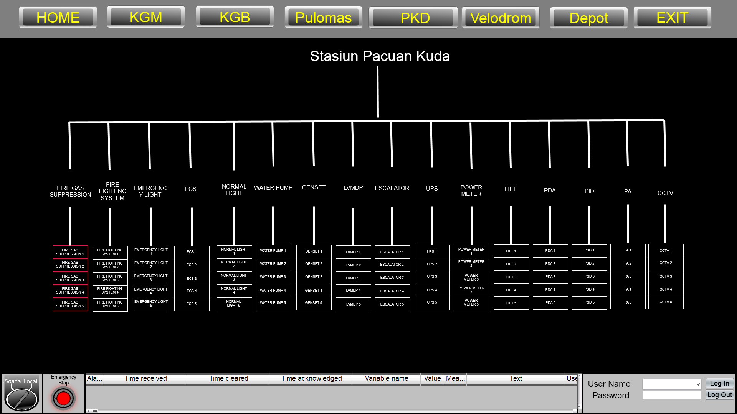

Figure - BMS Failure Status Display

* + - 1. Power Main Screen

Picture below show the concept of the Power Main Screen. From this view, we could select the specific display listed below:

* 20kV
* DC SWG
* Aux. Power

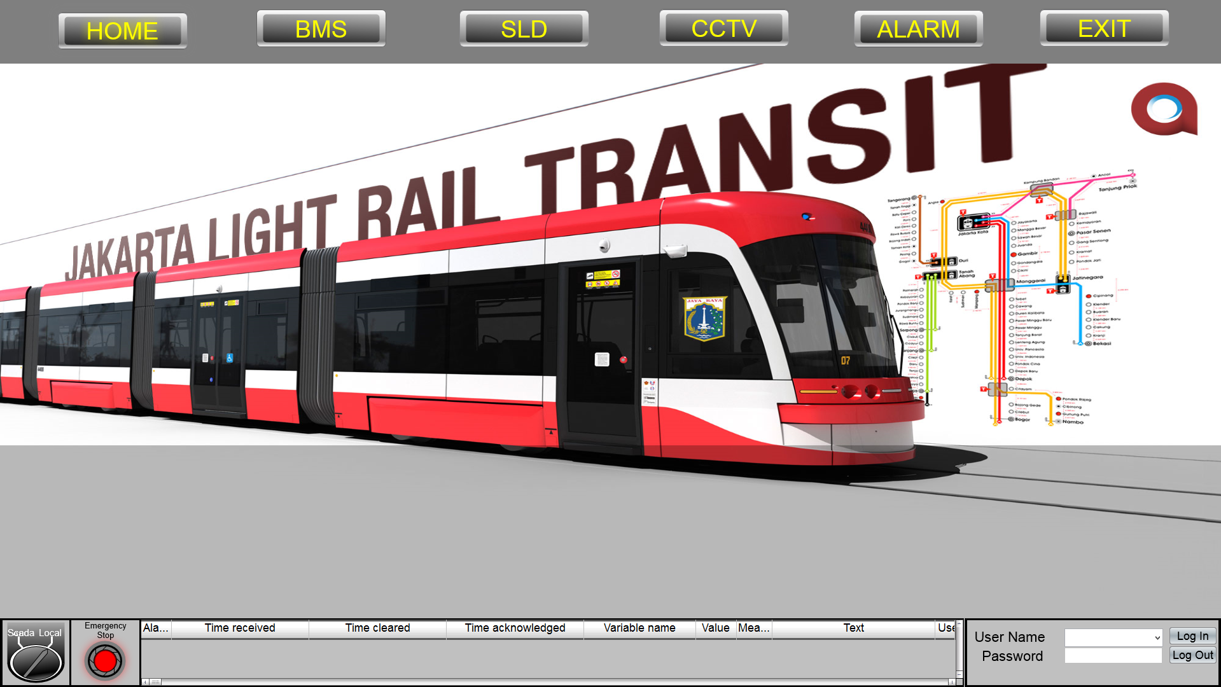

Figure - Main Power Home Screen

Picture below show the concept of the 20kV screen shot. 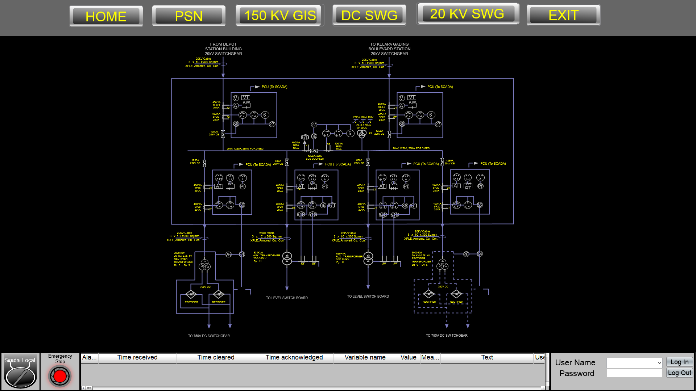

Figure - 20kV Screenshot

* 1. SCADA - Signalling System Design and Functionality

Following shown drawing of SCADA System and Signalling System Connection diagram



Signalling

SCADA

Figure 26 - SCADA and Signalling System Connection diagram

SCADA System will be connecting with the Signalling sistem through server to server at the OCC. The connection will use ethernet communication with redundancy configuration.

Following shown block diagram of SCADA System and Signalling System operational concept.



Figure 27 - SCADA and Signalling System Operational Concept

* 1. SCADA system will need data from signalling system for monitoring status and alarm of signaling system. So, SCADA System will need but not limited to following data from signalling system:
* Signalling Equipment status and alarm
* Train Schedule
* Train position or other data that can be used to determine train approaching or departing or etc.
  1. SCADA system will provide data and controlling PA system
  2. SCADA system will provide data and controlling PID system
  3. TPSS system will provide status of 3rd rail power availability
  4. The signaling system will only need data of the availability status of power supply for the train movement from SCADA system
  5. All status and alarm informed to SCADA operator
  6. SCADA operator will give response and call technician to checking related alarm
  7. Technician will follow up SCADA operator report and troubleshooting
  8. After checking the alarm, technician give troubleshooting status (solved, waiting spare part, etc) to SCADA operator
  9. SCADA - Traction Power Substation Design and Functionality

Following shown drawing of SCADA System Traction Power Substation Connection diagram.



Figure - SCADA Traction Power Substation Connection Diagram

According to the drawing above, the interface between SCADA system and Traction Power Substation system will be done in two ways, which are:

* Through Local Control
* Through SCADA RTU (I/O)

Connection between SCADA Local Control with the Traction Power Substation will be in the form of ethernet communication and is recommended using IEC 61850 protocol. The number of ethernet communication connection can be more than 1 (need to check with other party for the number of connection). The ethernet communication will preferably used if the Traction Power Substation device or equipment have ethernet communication feature.

The other scenario for SCADA System and Traction Power Substation connection is using hard wired connection through marshalling panel. For this case, SCADA system will install I/O RTU (remote terminal unit) to interface with Traction Power Substation marshalling panel through hard wire connection.

Following shown block diagram of SCADA System and Traction Power System operational concept.



Figure - SCADA System and Traction Power System Operational Concept

* 1. SCADA System will monitor status, alarm and measurement of but shall not be limited to following TPSS/APSS equipment:
* 20 kV Switchgear
* Transformer
* Rectifier
* DC Switchgear
* LV Switchgear
* Battery Charger

1. All status and alarm informed to SCADA operator
2. SCADA operator can give command to TPSS/APSS remote operation
3. SCADA System will send command to TPSS/APSS equipment
4. SCADA operator will give response and call technician to checking related alarm
5. Technician will follow up SCADA operator report and troubleshooting. If pickup relay activated, technician need to reset at switchgear locally
6. After checking the alarm, technician give troubleshooting status (solved, waiting spare part, etc) to SCADA operator
   * 1. Emergency DC Mass Trip System

Refer to the document technical specification 362748-MMI-MVI1-XX-SP-000-0010 Technical Specification_RevA

Clause 7.12 in the Traction Power Substations (TSS)

* Emergency DC mass trip (based on SCADA signal or local push-button), to switch out all conductor rail sections and Transformer Rectifier Units (TRU5) at a given location (note this will require tripping of some DC CBs at adjacent sites)
* Emergency mainline mass-trip (all DC circuit breakers) at the Electrical Control Desk in the Operational Control Centre.

SCADA design the emergency DC mass trip button in the traction power SCADA console screen. Only authorized operator can access this authority with specific login.

Procedure to activate emergency trip button system:

1. OCC Operator with the authority access display the traction power SCADA console
2. If any emergency condition or special case need shutdown all conductor rail sections, operator can push the the emergency trip button
3. Message window confirmation will appear to confirm with yes or no choice
4. If operator confirm to shutdown, SCADA trough RTU will send opening command to all DC switchgear in each traction power substation. To prevent any closing command from local / remote, inhibit signal also activated.

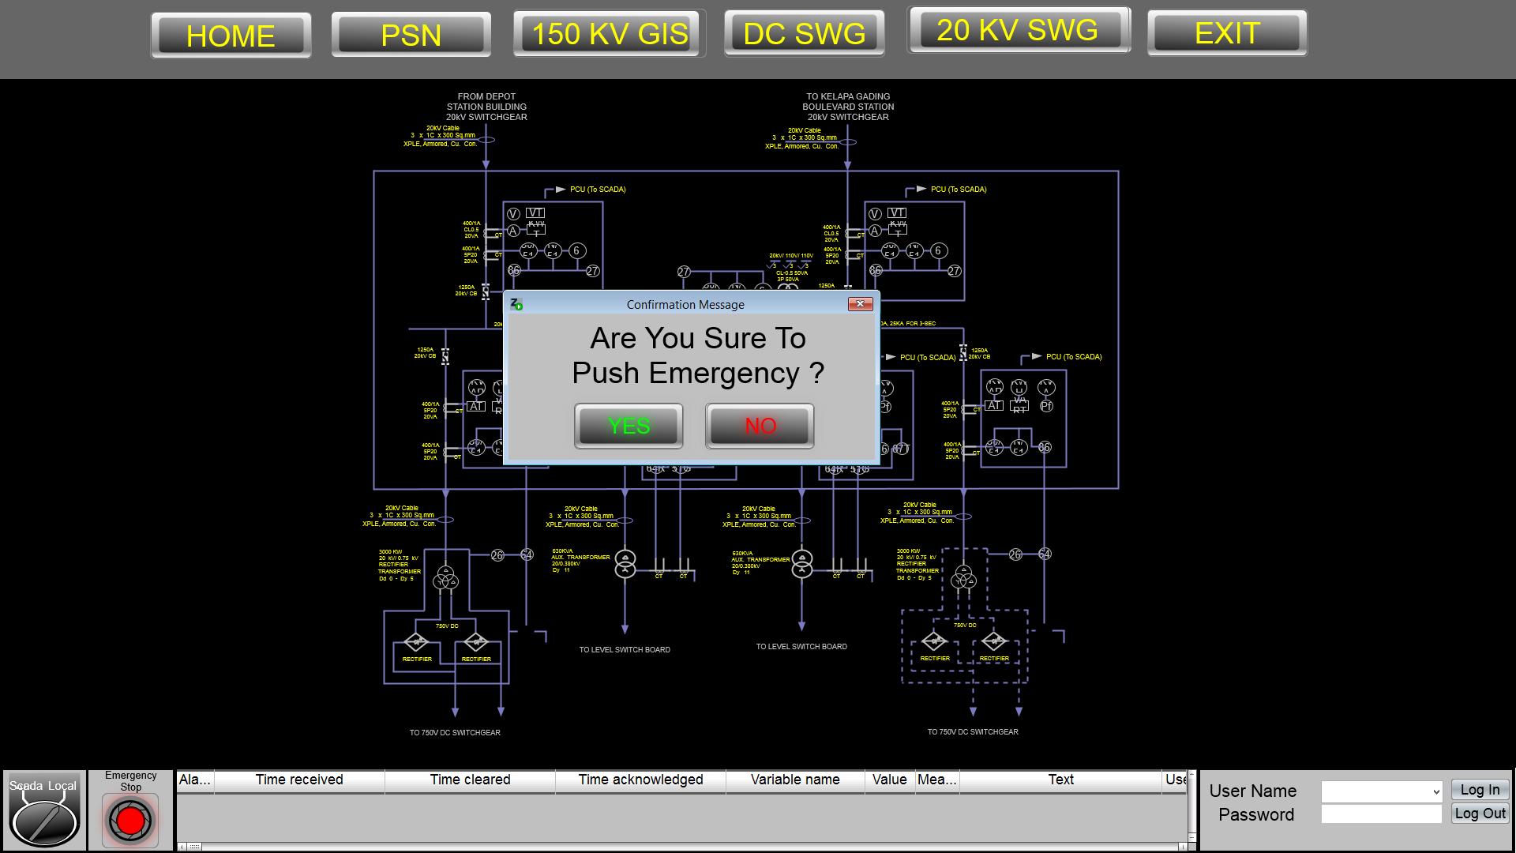

Confirmation windows

Emergency trip button

Figure - Emergency trip button

Procedure to releasing emergency trip button system:

1. After normal condition confirmed, OCC operator can push release button.
2. Message window confirmation will appear to confirm with yes or no choice
3. If operator confirm to release, SCADA trough RTU will deactivate inhibit signal.
4. Then OCC operator can give closing command to each DC switchgear by sequence.
   1. SCADA - Building Management System (BMS) Design and Functionality

Building Management System (BMS) is a local control system which control all equipment for running service on building. Building Management System will consist of but not limited to BMS Processor Unit, analog and/or digital I/O unit, and BMS Workstation. All operator interface to control building equipment locally will be done by BMS Workstation and will be processed by BMS Processor Unit.

SCADA System will be interfaced and connected to Building Managemen System (BMS) in the form of Ethernet Communication to BMS Processor or Workstation (To be discussed on the interface meeting with BMS). SCADA System will be connected to all Building Management System on each Station. Following are the drawing that shown connection diagram between SCADA System and Building Management System.



Figure - SCADA System and Building Management System Connection Diagram

Building Management System (BMS) are controlling and monitoring but not be limited to the following subsystem:

| **Equipment** | **BMS** | **SCADA** |
| --- | --- | --- |
| MCFA | Monitor | Monitor |
| Fire Fighting Pump (Electric pump) | Monitor | Monitor |
| Fire Fighting Pump (Diesel pump) | Monitor | Monitor |
| Fire Fighting Pump (Jockey pump) | Monitor | Monitor |
| Water Pump (Filter pump) | Monitor | Monitor |
| Water Pump (Booster pump) | Monitor | Monitor |
| Domestic Water Tank | Monitor | Monitor |
| Rain Water Tank | Monitor | Monitor |
| Fire Water Tank | Monitor | Monitor |
| Lighting | Control & Monitor | Control & Monitor |
| ECS (Exhaust fan) | Control & Monitor | Monitor |
| ECS (VRV) | Control & Monitor | Control & Monitor |
| Generator | Monitor | Monitor |
| Weekly tank (Generator) | Monitor | Monitor |
| Power Meter (Transformer) | Monitor | Monitor |
| UPS | Control & Monitor | Monitor |
| Elevator | Monitor | Monitor |
| Escalator | Monitor | Monitor |
| LV Switchgear | Monitor | Monitor |

Table - BMS and SCADA Controlling and Monitoring List

SCADA system will monitor and control all the subsystem above through Building Management System (BMS). SCADA system will control Building System in the form of normal mode of operation. SCADA System control command which will be proposed are on but not be limited to the following:

* Normal Operation Station Day on Command
* Normal Operation Station Night on Command
* Normal Operation Station Off Command

Normal Operation Station Day/Night On means that all the subsystem and equipment need by building to function for normal operation should be switch on. And Normal Operation Station Off means that some part of the subsystem or equipment still need to be switched on for preparation of the next operation, but all the subsystem or equipment that not needed will be switched off.

If some subsystem or equipment need to be service, BMS should run on service mode and the SCADA system will detect that the BMS is running on service mode. In this mode, Control authority will be set locally through BMS Workstation and SCADA system will not be allowed to send control command to the BMS. In service mode, BMS will be allowed to control the subsystem or equipment individualy for service purposes.

* 1. SCADA - PA/PID/VoIP/PHP System Design and functionality

To Monitor and Control of PA/PID/VoIP/PHP System, SCADA System will have server to server connection with the PA/PID/VoIP/PHP system at the OCC. Following shown drawing of SCADA and PA/PID/VoIP/PHP System connection diagram.

**

PA/PID/VoIP/PHP

SCADA

Figure - SCADA and PA/PID/VoIP/PHP System Connection Diagram

So, All of PA/PID/VoIP/PHP System will have and integrated server in redundant configuration for all subsystem to be connected with SCADA System (need to check with other party).

* + 1. SCADA - Public Announcement (PA) System

Public Announcement (PA) System is system which handle of voice announcement to the passanger as well as to the operator and station authority according to the purposes of the announcement. Public Announcement (PA) system will be installed on each station and should have but not be limited to the following zoning for announcement:

* Platform Area
* Public Area
* Non-Public Area

Public Announcement system will also have server which located at the OCC to centralize all of the PA system. For Monitoring and Controlling purposes, SCADA System will be connected to the Public Announcement (PA) System by interfaced with PA Server at OCC. SCADA System will monitor for health status and alarm of the PA system through the above connection. SCADA System will also be allowed to control PA System in the form of the following command:

* Making Long Line Public Address (LLPA)
* Making Autimatic Long Line Public Address (ALLPA) base on signalling system information.
* Making Pre-Recorded Annoucements.

Manual Announcement Operation Mode means that the announcement operation process will be done manually by the operator. In Manual Announcement Mode, Operator can make live announcement as well as pre-recorded announcement. In Manual Announcement Operation Mode, Operator should select manually for the station, zone, and also for the pre-recorded announcement if the operator decides to make pre-recorded announcement. This announcement also can be configured to be cyclical or just one-time announcement.

Automatic Announcement Operation Mode will only use pre-recorded announcement. The Automatic Announcement Operation Mode will be able to be configure by the operator. Automatic Announcement Operation Mode will be applied regarding of the following operation:

* Train Information Announcement
* Alarm information on the particular station (Fire Alarm)
* Pre-Configured Information on the particular station.

Train information Announcement consist of the following information:

* Next Train expected arrival time announcement
* Train Approaching and passanger warning according to the train approaching announcement.

Train Information Announcement will only announce at the zone platform to give information to the passanger at the related platform area.

Alarm information announcement will be categorize based on the alarm purpose. This can be based on alarm level, location, or intended actor (public or non-public).

Pre-Configured Information Announncement is the announcement on the particular station and zone that will be created by the operator.

* + 1. SCADA - Public Information Display (PID)

Public Information Display (PID) is a system or equipment that will be displayed a text message information. PID system should be integrated with the PA System, So SCADA System will automatically be interconnected with the PID system, because it has been connected with PA System at PA Server in the OCC.

The PID Display will be in the form of LED dot matrix display panels, so it will be mainly used to display real time train arrival information. SCADA System will monitor PID system equipment for health status and alarm. And also, SCADA system will be allowed to send command control to the PID system in the form of the following:

* Sending Text Message.

There will be two mode of messaging PID System by SCADA System, which are:

* Manual Messaging Mode
* Automatic Messaging Mode

Manual Messsaging Mode will be used for operator to display message on the PID display manually. In this mode, operator need to enter the message he or she want to display. The Message will also able to be configured cyclical in the specific time or just one time message.

Automatic Messaging Mode will be applied regarding of the following operation:

* Train information message

Train Information Message will be displayed but should not be limited to the following information:

* Next Train Expected Arrival Time
* Train Approaching.
  + 1. SCADA - VoIP and Passanger Help Point (PHP)

For the Voice Over IP (VoIP) System, SCADA system will only monitor for equipment health status and alarm. So, there will be no command control from SCADA system to the VoIP System.

Passanger Help Point (PHP) System will consist of intercom like communication equipment which will be installed usually at the elevator to allow for the passenger to communicate with the operator.

Following shown block diagram of SCADA System and PHP system operational concept.



Figure - SCADA System and PHP system Operational Concept

* 1. When a passanger initiate communication with the operator through PHP device,
  2. PHP system will pass to CXS Server which will further send the status of PHP to SCADA system
  3. SCADA system will monitor this action, indication for the active PHP equipment in SCADA Workstation to inform the operator at OCC that there is a call from the passenger through PHP System. Operator then can decide to take the call from PHP Equipment
  4. Send the information to the CCTV process to point particular camera to the active PHP equipment, and zoom in if necessary
  5. All status and alarm informed to SCADA operator. SCADA operator will give response and call technician to checking related alarm
  6. Technician will follow up SCADA operator report and troubleshooting
  7. After checking the alarm, technician give troubleshooting status (solved, waiting spare part, etc) to SCADA operator
  8. SCADA - AMS/CCTV System Design and Functionality

Following Shown drawing of SCADA – AMS/CCTV Connection diagram.



Figure - SCADA – AMS/CCTV System Connection Diagram

For the Access Management System (AMS), SCADA system will only monitor for equipment health status and alarm. So, there will be no command control from SCADA system to the AMS. The status and alarm data will be gather from AMS/CCTV Server.

CCTV System will consist of IP Based Camera that can be accessed using TCP/IP communication. SCADA system will require to access CCTV camera for live streaming only. All recording will be done by CCTV Server. But, when in Control Room layout SCADA workstation is happened to be side by side with CCTV Workstation, then SCADA System will no need to access and display CCTV camera image.

When there is necessary alarm need to show for live streaming image or PHP Intercom active, SCADA System will detect such information and will access particular CCTV camera, point to appropriate location and zoom in if possible. Then SCADA Workstation will display the image from particular CCTV Camera.

If SCADA Workstation will not display camera live streaming because of there is CCTV Workstation, then SCADA System will pass the above information (alarm and active PHP System) to the CCTV server.

SCADA System will also monitor CCTV System equipment for health status and alarm. The status and alarm data can be gather from AMS/CCTV Server, or from CCTV Camera device directly.

* 1. SCADA - Other System design

For other system, SCADA system will only monitor for health status and alarm of the equipment. There will be three kinds of connection between SCADA System and Other system, which are:

* Server to Server Connection
* Through SCADA Local Control at Station
* SCADA Server to device directly.

Following are table of the other system connection type plan to scada server (this connection type can be changed based on the interface with other party).

|  |  |  |
| --- | --- | --- |
| No | System | Connection Type (need to check with other party) |
| 1 | Radio Tetra | Server to Server Connection |
| 2 | Master Clock System | Server to Server Connection |
| 3 | Automatic Fair Collection (AFC) | Server to Server Connection |
| 4 | Fibre Optic Transmission System (FOTS) | SCADA Server to device directly |
| 5 | Platform Screen Door (PSD) | SCADA Local Control to Other System |
| 6 | Wide Area Network (WAN) | SCADA Server to device directly |

Table - SCADA Interface with other Party

Following are drawing of the connection type between SCADA System and Other System.



Figure - SCADA Connection with Other Party

* 1. SCADA Wall Display Design

SCADA System will be equipped with a computer that will be use as SCADA wall display controller. This SCADA wall display controller will organize the basic overall view of the subsystem being controlled by SCADA System. SCADA Wall Display Controller will be the client of SCADA Server. Following are the plan of the overall view that will be displayed by wall display controller:

* Traction Power Substation Overall View
* Building Overall View
* Telecommunication and Utility Overall View

Each of the overall view above will be displayed with 2 video ports. So, Total will be 6 video ports. This port will be connected to OCC Display Controller Matrix. The decision which kind of information would be displayed to wall controller, will be controlled by OCC Display Controller. So, SCADA Wall Controller will only supply the video information need to be displayed. Following shown drawing of SCADA Wall Display Design Interface diagram.



Figure - SCADA Wall Display Design Interface Diagram

* 1. HMI SCADA Sytem BoQ

| **NO** | **DESCRIPTION** | **BRAND** | **PART #** | **QTY Need** | **UNIT** |
| --- | --- | --- | --- | --- | --- |
|  | **SERVER RACK** |  |  |  |  |
| **A** | **SERVER** |  |  |  |  |
| 1 | Server PC Processor Intel Xeon E5-2620 v4 Memory 32 GB (2x HPE 16GB 1Rx4 PC4-2400T-R Kit) HP Smart Array P440ar/2G FIO Controller 2x HPE 300GB SAS 10k SFF SC HDD 2x HPE 600GB SAS 15K SFF SC HDD HP Embedded 1Gb Ethernet 4-port 331i Adapter HPE 900W Standard AC 240VDC Redundant Power Supply Kit HPE iLO Adv incl 3yr TSU 1-Server License HPE 5Y Proactive Care 24x7 Service | Hewlett Packard | ProLiant DL180 Gen9 | 2 | EA |
| **B** | **SOFTWARE** |  |  |  |  |
| 1 | Operating System | Microsoft | Windows Server 2016 x64 | 2 | LIC |
| 2 | Zenon EE Server 1500 TAGs | Zenon | ZEE7-SRV-1500 | 2 | LIC |
| 3 | Dongle | Zenon | DIV-DONG-USBCM | 2 | LIC |
| 4 | Reporting (Write Access) | Zenon | ZM-REPORT | 2 | LIC |
| **C** | **PANEL BOX COMPONENT & ACCESSORIES** |  |  |  |  |
| 1 | Server Rack HPE 42U 600x1075mm Enterprise Shock Rack HPE LCD 8500 1U Console INTL Kit HPE 600mm Rack Stabilizer Kit HPE 42U 1075mm Side Panel Kit HPE Rack Grounding Kit HPE 0x1x8 G3 KVM Console Switch 8x HPE KVM USB Adapter 2x HPE Intelligent 7.3kVA/INTL PDU Kit HPE IP CAT5 Qty-8 6ft/2m Cable | Hewlett Packard | 42U Rack 19” | 1 | EA |
| 2 | MCB 2 POLE 16 A | Tba |  | 2 | EA |
| 3 | Terminal Block | Tba |  | 1 | LOT |
| 4 | Power Socket | Tba |  | 2 | EA |
|  |  |  |  |  |  |
|  |  |  |  |  |  |
| **NO** | **DESCRIPTION** | **BRAND** | **PART #** | **QTY Need** | **UNIT** |
|  | **WORKSTATION** |  |  |  |  |
| **A** | **WORKSTATION** |  |  |  |  |
| 1 | Workstation PC 700W 90 Percent Efficient Chassis Win 10 Pro 64 INDO Operating System Load to SATA/SAS Intel Xeon E5-1603v4 2.80GHz 10MB 2133 4C CPU 8GB DDR4-2400 (1x8GB) Registered RAM NVIDIA Quadro M2000 4GB 4xDP 1st No cable included Graphics 1TB 7200 RPM SATA 1st Hard Drive HP USB Business Slim Keyboard SING HP USB Optical Mouse 19.5mm Slim SuperMulti DVDRW 1st ODD HP 3/3/3 Warranty SING HP DisplayPort To VGA Adapter HP DisplayPort To VGA Adapter 2nd HP DisplayPort To VGA Adapter | Hewlett Packard | Z440 Workstation | 1 | EA |
| 2 | LED Monitor 24-inch IPS LED Resolution 1920 x 1080 (16:9) Input VGA & HDMI | Hewlett Packard | N240 | 2 | EA |
| **B** | **SOFTWARE** |  |  |  |  |
| 1 | Zenon EE Client 1500 TAGs | Zenon | ZEE7-CLI-1500 | 2 | LIC |
| 2 | Dongle | Zenon | DIV-DONG-USBCM | 2 | LIC |
| 3 | Reporting (Write Access) | Zenon | ZM-REPORT | 2 | LIC |
| **C** | **WORKSTATION DESK & ACCESSORIES** |  |  |  |  |
| 1 | Workstation Desk | Tba |  | 1 | EA |
| 2 | MCB 2 POLE 10 A | Tba |  | 1 | EA |
| 3 | Terminal Block | Tba |  | 1 | LOT |
| 4 | Power Socket | Tba |  | 1 | EA |

* 1. Cabling System
     1. CAT 6 Cable

SCADA equipments connected to the SCADA LAN as well as Ethernet cable will be using Cat 6 cable.

|  |  |  |
| --- | --- | --- |
| Actassi F2 Category 6 UTP Cable or Equivalent | | |
| No | Description | Technical Spesifications |
| 1 | Conductor | Solid Bare Copper |
| 2 | Jacket | PVC |
| 3 | Separator | F2 Construction (PE) |
| 4 | Insulation | PE |
| 5 | AWG | 23 (0.58mm) |
| 6 | Reference Standard | TIA/EIA 568B.2-1 & ISO/IEC 11801, IEC61156-5 |
| 7 | Product Standard | UL |
| 8 | Certification | Flammability Test CM Fire rated |

Table CAT 6 Cable's Spesification

* + 1. AC Power Cable 4 Core

Copper Conductor PVC Insulated & PVC Sheathed Armoured Power Cable 41 A is used to connect the power source from existing electrical distribution board to the server, switch and workstation of SCADA.

| Cu/PVC/SWA/PVC 0.6/1 kV (NYRGbY) | | |
| --- | --- | --- |
| No | Description | Technical Spesifications |
| 1 | Spesification | SPLN 43-2 : 1994  IEC 60502-1 : 2004  SNI IEC 60502-1 : 2009 |
| 2 | Conductor | Annealed plain copper round circular stranded according to SPLN 41 - 1 ; IEC 60228 |
| 3 | Insulator | Extruded layer of Polyvinyl Chloride (PVC] complied with SPLN 41-2 : IEC 60502-1 |
| 4 | Armour Material | A layer of galvanized round steel wires with a counter helix layer of galvanized steel tape |
| 5 | Outer Sheath | Extruded Polyvinyl Chloride [PVC] Black color |
| 6 | No. of cores and cross  secton area | 4 x 4 sq.mm |
| 7 | Current Rating | 41 A |
| 8 | Voltage Rating | 1kV |
| 9 | DC Resistance at 20C | 50 Ohm/Km |
| 10 | Temperature | 70C |
| 11 | Indentification | (SNI IEC) Yellow/Green Strip, Light Blue,Brown. |
| 12 | Special Feature | Low Smoke Zero Halogen |

Table Tehnical Cable's Spesification for AC Power

* + 1. Earthing Cable

Single Core Flexible Copper Conductor PVC Insulated used to connect the SCADA equipment needed earthing to earthing bar.

| Cu/PVC/PVC 450/750 V (NYAF) | | |
| --- | --- | --- |
| No | Description | Technical Spesifications |
| 1 | Spesificatio006E | SPLN 42-3 1992  IEC 227  SNI: 04-6629.5-2006 |
| 2 | Conductor | Annealed plain copper wires bunch stranded, according to SPLN 41-1; IEC 60228 |
| 3 | Insulator | Extruded layer of Polyvinyl Chloride [PVC] complied with SPLN 41-2 |
| 4 | Nominal Cross Section Area | 10 sq.mm |
| 5 | No. of wire and Diameter | 84./0.4 mm |
| 6 | Nominal thickness Insulation | 1.0 mm |
| 7 | Overall Diameter (approx) | 7.4 mm |
| 8 | Weight of Cable (approx] | 116 Kg/Km |
| 9 | Minimum Bending Radius | 133 mm |
| 10 | DC Resistance at 20C | 1.91 Ohm/Km |
| 11 | Temperature | 70C |
| 12 | Indentification | Yellow green strip |

Table Technical Cable's Spesification for Power and Chassis Grounding

* 1. Earthing System
     1. Introduction

Earthing (grounding) is an important part of electrical design.

Earthing system is an electrical bond between a given point in a network, installation or machine and an earth electrode.

The purpose of earthing systems is to:

* Prevent hazardous voltages due to system faults
* Prevent disturbances to electronics
* Minimise danger and damage due to lightning strikes
* Ensure the fast operation of protection devices
  + 1. Grounding of SCADA Equipment

All the electrical apparatus SCADA which required common ground will be bonded to the earth bar using the copper cable in PVC sheath. The method of the bonding will be based on a crimped lug bolted at both end of the copper cable between the earth bar and the electrical apparatus.

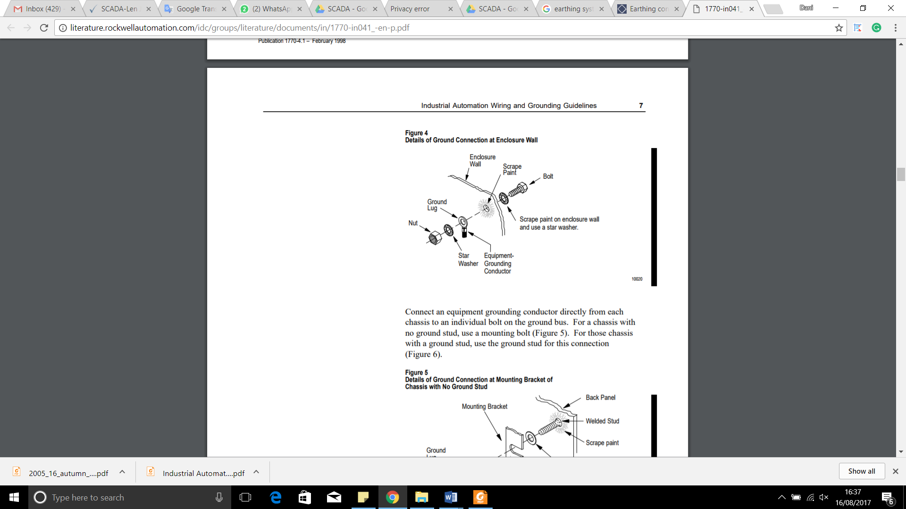

Figure Detail of Ground Connection

Besides bonding the electrical apparatus, the metallic chassis of the apparatus such as panel door mounting plate inside the panel will be bonded to the earth bus bar.

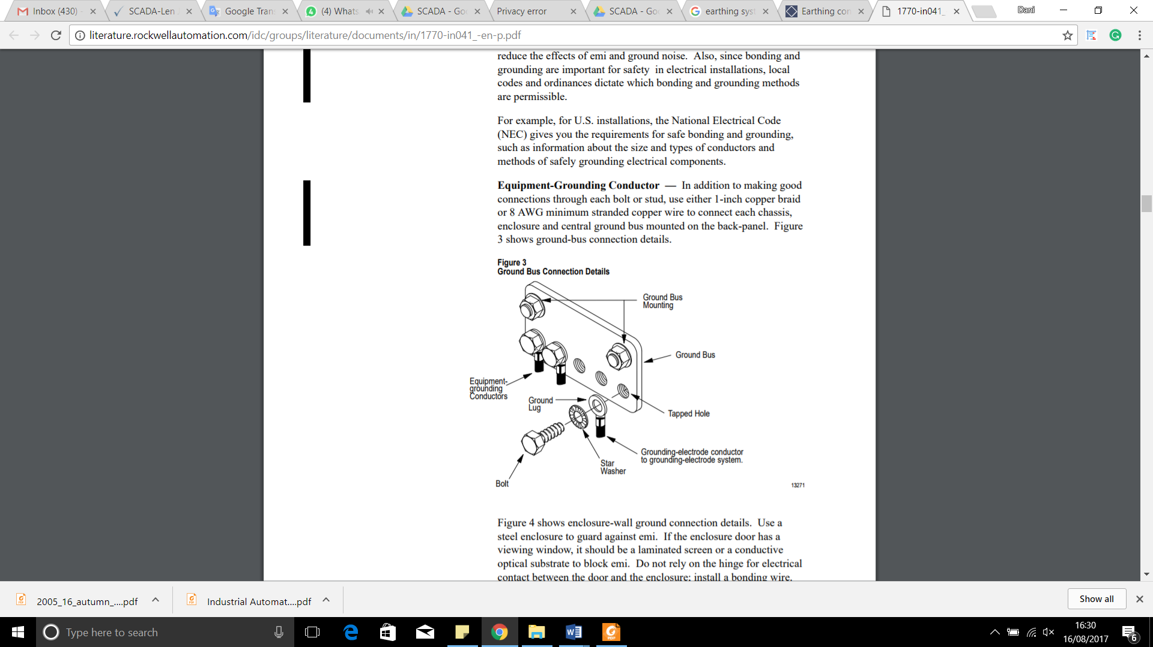

Figure Ground Bus Bar Connection Details

The ohmic requirement for the main earth bar terminal (provided by others) shall be not more than 1 ohm.

# Electromagnetic compatibility

Electromagnetic compatibility is the condition that prevails when telecommunications equipment is performing its individually designed function in a common electromagnetic environment without causing or suffering unacceptable degradation due to unintentional electromagnetic interference to or from other equipment in the same environment.

The SCADA system equipment provided in the Jakarta LRT project will be electromagnetically compatible with their environments and in accordance to the EMC standards as stated in the contract. SCADA system in this project, regarding from compliance matrix in previous section, will be according to BS EN 61000 - Electromagnetic compatibility (EMC).

|  |  |  |  |
| --- | --- | --- | --- |
| **No.** | **Product** | **Part Number** | **EMC Standard** |
| 1 | Color Laserjet Printer | HP MFP M177fw | CISPR 22:2008 /EN 55022:2010 - Class B, EN 61000-3-2:2006 +A1:2009 +A2:2009, EN 61000-3-3:2008, EN 55024:2010, FCC Title 47 CFR, Part 15 Class B / ICES-003, Issue 5, GB9254-2008, GB17625.1-2003, EMC Directive 2004/108/EC (Europe) |
| 2 | Black and White Printer |  | TBA |
| 3 | OCC and BOCC Server | HP HPE ProLiant DL380 Generation 9 (Gen9) | FCC Rating Class A  CISPR 22; EN55022; EN55024; FCC CFR 47, Pt 15; ICES-003; CNS13438; GB9254; K22; K24; EN 61000-3-2; EN 61000-3-3; EN 60950-1; IEC 60950-1 |
| 4 | Station Server (Typical) | HP HPE ProLiant DL180 Generation 9 (Gen9) | FCC Rating Class A  CISPR 22; EN55022; EN55024; FCC CFR 47, Pt 15; ICES-003; CNS14336-1; CNS13438; GB4943; GB9254; EN 61000-3-2; EN 61000-3-3; EN 60950-1; IEC 60950-1 |
| 5 | SCADA Workstation |  | TBA |

# RAMS Model

The SCADA System is targeted to meet the SIL 2 based on IEC 61508. This section describes the RAMs model and calculation for the SCADA System towards achieving the availability level.

The following picture depict the hardware configuration and SIL 2 Boundary.



Figure – SCADA System SIL 2 Boundary

The following table shows the MTBF and MTTR numbers of the SCADA system:

|  |  |  |  |
| --- | --- | --- | --- |
| **Equipment** | **MTBF (Hr)** | **MTTR (Hr)** | **Availability** |
| **OCC SCADA Server** | 50,000 | 0.5 | 0,9999999999 |
| **OCC HMI Workstation** | 50,000 | 0.5 | 0,9999999999 |
| **Local SCADA Server** | 50,000 | 0.5 | 0,9999999999 |
| **Local HMI Workstation** | 50,000 | 0.5 | 0,99999 |
| **RTU** | 120,000 | 0.5 | 0,999999999983 |

Table - Equipment MTBF, MTTR and Availability Summary

The MTBF is the number of hours before an occurrence of a failure in the SCADA system device. The MTTR is the mean time to repair of the SCADA system. The MTTR specified is the time that is only relevant to the SCADA system and does not take into account any time that is consumed outside of the troubleshooting and repair time of the SCADA system. The following diagram shows the interconnections of the SCADA setup and the availability calculation with assumption that all other subsystems are in ideal conditions.



Figure – SCADA System Configuration



Figure – SCADA System Availability calculation

Based on the above figures, the Availability of the SCADA System can be calculated as below:

* Availability of Parallel OCC SCADA Server = 1- (0,00001) (0,00001)
* Availability of Parallel OCC SCADA Server = 0,9999999999
* Availability of Parallel OCC HMI Workstation = 1- (0,00001) (0,00001)
* Availability of Parallel OCC HMI Workstation = 0,9999999999
* Availability of Parallel Local SCADA Server = 1- (0,00001) (0,00001)
* Availability of Parallel Local SCADA Server = 0,9999999999
* Availability of Local HMI Workstation = 1-0,00001
* Availability of Local HMI Workstation = 0,99999
* Availability of Parallel RTU = 1-(4,167E-06) (4,167E-06)
* Availability of Parallel RTU = 0,999999999982639
* Availability of SCADA system = 1 – Unavailability {Parallel OCC SCADA Server+Parallel OCC HMI Workstation+ Parallel Local SCADA Server + Local HMI Workstation +Parallel RTU}
* Availability of SCADA system = 1- [(0.00001) (0.00001) + (0.00001) (0.0001) + (0.00001) (0.00001) + (0.00001) + (4,167E-06) (4,167E-06)]
* Availability of SCADA System = 1- 0,0000100003173611111
* Availability of SCADA System = 0,999989999682639
* Availability of SCADA System = 99,9989999682639%

# Appendix

Appendix A: Compliance List Matrix

Appendix B: List of Drawings

Appendix C: SIL 2 Certificate

Appendix D: Technical Spesification of SCADA

Appendix E: IO List (not confirm)

APPENDIX A:

Compliance List Matrix

| **NO** | **REQUIREMENTS** | **COMPLIANCE** | | | | **CONTENT TYPE** | | **Requirement's Evidence (Document Reference)** | **NOTE** |
| --- | --- | --- | --- | --- | --- | --- | --- | --- | --- |
| **Compliant** | **Partially-Compliant** | **Non-Compliant** | **Discrepancy** | **Requirement** | **Information** |
|  | **Standards for SCADA** | | | | | | | | |
| 1 | BS 7430 - Code of practice for protective earthing of electrical installations | √ |  |  |  |  |  | Section 1.2.2 Standard References |  |
| 2 | BS 7671 - Requirements for electrical installations. IET Wiring Regulations. 17th edition | √ |  |  |  |  |  | Section 1.2.2 Standard References |  |
| 3 | BS EN 50121 - Railway applications. Electromagnetic compatibility | √ |  |  |  |  |  | Section 1.2.2 Standard References |  |
| 4 | BS EN 50122 - Railway applications. Fixed installations. Electrical safety, earthing and the return circuit | √ |  |  |  |  |  | Section 1.2.2 Standard References |  |
| 5 | BS EN 50125 - Railway applications. Environmental conditions for equipment | √ |  |  |  |  |  | Section 1.2.2 Standard References |  |
| 6 | BS EN 50126 - Railway applications. The specification and demonstration of reliability, availability, maintainability and safety (RAMS) | √ |  |  |  |  |  | Section 1.2.2 Standard References |  |
| 7 | BS EN 50128 - Railway applications. Communication, signalling and processing systems. Software for railway control and protection systems | √ |  |  |  |  |  | Section 1.2.2 Standard References |  |
| 8 | BS EN 50129 - Railway applications. Communication, signalling and processing systems. | √ |  |  |  |  |  | Section 1.2.2 Standard References |  |
| 9 | BS EN 50174 - Information Technology. Cabling installation | √ |  |  |  |  |  | Section 1.2.2 Standard References |  |
| 10 | BS EN 50288-7 - Multi-element metallic cables used in analogue and digital communication and control | √ |  |  |  |  |  | Section 1.2.2 Standard References |  |
| 11 | BS EN 50310 - Application of equipotential bonding and earthing in buildings with information technology equipment | √ |  |  |  |  |  | Section 1.2.2 Standard References |  |
| 12 | BS EN 60073 - Basic and safety principles for man-machine interface, marking and identification. Coding principles for indication devices and actuators | √ |  |  |  |  |  | Section 1.2.2 Standard References |  |
| 13 | BS EN 60529 - Degrees of protection provided by enclosures (IP code) | √ |  |  |  |  |  | Section 1.2.2 Standard References |  |
| 14 | BS EN 60617 - Graphical symbols for diagrams | √ |  |  |  |  |  | Section 1.2.2 Standard References |  |
| 15 | BS EN 60870 - Tele-control equipment and systems | √ |  |  |  |  |  | Section 1.2.2 Standard References |  |
| 16 | BS EN 60950 - Information Technology Equipment. Safety | √ |  |  |  |  |  | Section 1.2.2 Standard References |  |
| 17 | BS EN 61000 - Electromagnetic compatibility (EMC) | √ |  |  |  |  |  | Section 1.2.2 Standard References |  |
| 18 | BS EN 61131 - Programmable controllers | √ |  |  |  |  |  | Section 1.2.2 Standard References |  |
| 19 | BS EN 61508 - Functional Safety of Electrical/Electronic/programmable electronic safety-related systems | √ |  |  |  |  |  | Section 1.2.2 Standard References |  |
| 20 | BS EN 62305 - Protection against lightning | √ |  |  |  |  |  | Section 1.2.2 Standard References |  |
| 21 | BS EN 62491 - Industrial systems, Installations and equipment and industrial products – labelling of cables and cores | √ |  |  |  |  |  | Section 1.2.2 Standard References |  |
| 22 | ISO 11801:2012 - Information technology - Generic cabling for customer premises - Amendment 2 | √ |  |  |  |  |  | Section 1.2.2 Standard References |  |
| 23 | All Indonesia National and Municipal Codes, Acts and Regulations that are related to the SCADA system | √ |  |  |  |  |  | Section 1.2.2 Standard References |  |
|  | **Functional Requirements for SCADA** | | | | | | | | |
| 1 | The SCADA system shall provide a centralised control function with appropriate SCADA facilities to provide the Operators with an efficient means of real-time monitoring and controlling the M&E plant and subsystems throughout the stations through the SCADA workstations. | √ |  |  |  |  |  | Section 2 System Description  Appendix A: SCADA Design Architecture |  |
| 2 | The core of the SCADA system shall comprise a pair of redundant servers, configured in a hot-standby configuration to provide resilience and secondary recovery control positions. The detailed designs and configuration of the SCADA system shall be considered to maximise system reliability and availability which will minimise operational risk. | √ |  |  |  |  |  | Section 5.1 Redudancy  Appendix A: SCADA Design Architecture |  |
| 3 | The SCADA system shall continuously monitor the status of M&E plant and subsystems. Equipment failures of M&E plant and subsystems shall generate alarms to the SCADA workstations which shall be automatically recorded and printed. The system shall provide comprehensive management information in the form of historical trends to enable the efficiency of station operation. | √ |  |  |  |  |  | Section 6.4.2 Alarm |  |
| 4 | The SCADA workstations shall provide high quality data presentation using the latest Graphic User Interface (GUI) techniques showing the operational status of M&E plant and subsystems by means of dynamic plan layouts, single-line diagrams and icons. | √ |  |  |  |  |  | Section 6.4.3 Screen Display Design |  |
| 5 | The SCADA system shall interface with the M&E plant and subsystems at the following locations:   * All stations * Depot * Traction power substations | √ |  |  |  |  |  | Section 6. General |  |
| 6 | The SCADA system shall be constructed in accordance with internationally recognised standards and designed for safe and efficient operation. All hardware and software of SCADA system shall be of a proven design and the major core components of the SCADA system shall have a service life of at least 15 years. | √ |  |  |  |  |  | Section 4.1 Zenon Product Family |  |
| 7 | The SCADA system shall be certified to a high and continuous demand SIL2 standard in accordance with BS EN 61508. | √ |  |  |  |  |  | Appendix B - SIL 2 Zenon Certificate  Appendix B - SIL 2 Allen - Bradley Certificate |  |
| 8 | The SCADA system shall meet, but not limited to the following requirements:   * Commercial-off-the-shelf (COTS) and modular construction solution. * Open proprietary system. * IP based and interfacing seamlessly with the M&E plant and subsystems. * Industrial grade with proven high quality and reliability, suitable for railway environment. * Supplied by proven system integrator with proven track record on rail systems. * Powered from UPS supplies to protect against failure of the incoming mains supplies. | √ |  |  |  |  |  | Section 2.2.5 Power Requirements  Section 4.1 Zenon Product Family  Section 8 RAMS Model |  |
| 9 | SCADA Servers / Workstations | | | | | | | | |
| 9.1 The OCC shall be installed with redundant SCADA servers; each console shall be installed with a SCADA workstation for the operation of the M&E plant and subsystems. | √ |  |  |  |  |  | Section 5.1 Redundancy  Appendix A: SCADA Design Architecture |  |
| 9.2 The SCADA servers and workstations shall use the most recent proven computer technology consisting of hardware and software. All system hardware and software shall be of a type already widely used for rail application with full service and support facilities available. | √ |  |  |  |  |  | Section 4.1 Zenon Product Family |  |
| 9.3 The SCADA servers shall be capable, in terms of processor and memory, to meet the performance requirements, including operator interface, database management, alarming and communication interfaces. The primary server shall handle communications with the RTUs, maintain the primary system database and interface with the SCADA workstations through the LAN in OCC or Fibre Optic Transmission System for those SCADA workstations that installed throughout the stations. | √ |  |  |  |  |  | Section 3 Hardware Description  Appendix A: SCADA Design Architecture |  |
| 9.4 The SCADA servers shall be configured in a hot-standby arrangement so that either server can immediately assume system mastership in the event of one server failure. Each server shall have two communication links to interconnect with two different network switches for receiving or transmitting I/O status from or to the fields RTUs, SCADA workstations or subsystems. | √ |  |  |  |  |  | Section 5.1 Redundancy  Appendix A: SCADA Design Architecture |  |
| 9.5 The SCADA servers shall utilise the LAN connection to monitor and control of other subsystems including CCTV System, Public Address (PA) System, Help Points System, Passenger Information Display (PID) System, etc. through the IP protocol. consistent at all times with the primary server’s database under normal conditions. | √ |  |  |  |  |  | Section Appendix A - SCADA Architecture Diagram System with Other System |  |
| 9.6 A real-time database duplication mechanism shall be implemented. The database duplication shall be performed on a per transaction basis to ensure that the secondary server’s database is consistent at all times with the primary server’s database under normal conditions. | √ |  |  |  |  |  | Section 2. System Description  Section 2.1.1 Functional Role  Section 5.1 Redundancy |  |
| 9.7 The secondary server shall provide identical functions as primary server, including data storage and data printing. Furthermore, the secondary server can take over the primary server’s function immediately without re-booting when a primary server failure occurs. The secondary server shall update the primary server’s database and handover the supervisory and control function back to the primary server once it has recovered. | √ |  |  |  |  |  | Section 5.1 Redundancy |  |
| 9.8 It shall be possible to remove one server for maintenance without interrupting system operation and, upon its reinstatement, re-synchronize the database without interruption to system operations. The Operator shall designate either server as the primary or secondary server through the SCADA workstations. | √ |  |  |  |  |  | Section 5.1 Redundancy |  |
| 9.9 Each SCADA workstation at OCC shall accommodate with four monitors. One monitor shall be dedicated to display CCTV images (spot monitor), and three monitors shall be used to display GUI graphics for overview stations display, overview traction power substations display and alarm status display for control and monitoring. | √ |  |  |  |  |  | Section 6.4.3 Screen Display Design  Section Appendix A: SCADA Design Architecture |  |
| 9.10 The design of the SCADA system shall be based on the concept that the operation from the OCC. However, the system design shall be such that control and backup of the system shall be possible from an alternate location. | √ |  |  |  |  |  | Section Appendix A: SCADA Design Architecture |  |
| 9.11 Each station shall be installed with a SCADA workstation that has the same basic system operations and functionality of the SCADA system. Each station SCADA workstation shall accommodate with three monitors. One monitor shall be dedicated to display CCTV images (spot monitor), and two monitor shall be used to display GUI graphics for overview station display and alarm status display of the particular station. |  |  |  | √ |  |  |  | SCADA Install two monitor typical in station. CCTV monitor provide by CCTV WPC |
| 9.12 All SCADA servers and workstations shall be configured with password access levels so that access to the operating control level is available only to Operator with the appropriate access rights. | √ |  |  |  |  |  | Section 2 SYSTEM DESCRIPTION  Section 4.1 Zenon Product Family    Section 4.4.5 User administration |  |
| 9.13 As a minimum, the SCADA workstations shall be comprised of colour monitors with a minimum size of 23.8”, diagonal non-glare flat LED screens and have a minimum resolution of 1920 X 1080 pixels. The SCADA workstations shall display with colour GUI diagrams the current status of the M&E plant and subsystems. | √ |  |  |  |  |  | Section 3.1.2 HMI Workstation Monitor |  |
| 9.14 Two black ink laser printers shall be provided. One printer shall be assigned for printing of recording alarms or event transactions, and the other printer shall be configured as standby. A colour laser printer that supports GUI graphics shall be provided and shall be assigned for printing of system reports and trending. | √ |  |  |  |  |  | Section 3.1.3 Color Printer  Section 3.1.4 Black and White Printer |  |
| 10 | **Remote Terminal Units** | | | | | | | | |
| 10.1 The SCADA system shall use the Remote Terminal Units (RTUs) to gather I/O status of M&E plant and subsystems from various stations. The RTU shall be of modular construction and proven reliability. | √ |  |  |  |  |  | Cover on Detail Design of RTU Document | Comply |
| 10.2 The RTUs shall be installed at stations, traction power substations and depot for control and monitoring of the various M&E plant and subsystems. Each location shall consist of redundant RTUs, install in different compartments within the local control panel. | √ |  |  |  |  |  | Cover on Detail Design of RTU Document | Comply |
| 10.3 The RTU for the traction power substations might need to be compatible with an IEC 61850 to provide parallel redundancy protocols for the Intelligent Electronic Device (IED) of switchgears. | √ |  |  |  |  |  | Cover on Detail Design of RTU Document | Comply |
| 10.4 The RTU shall use the most recent proven control technology consisting of hardware and software to implement complete functional systems. All system hardware and software shall be of a type already widely used for rail application with full service and support facilities available locally. | √ |  |  |  |  |  | Cover on Detail Design of RTU Document | Comply |
| 10.5 The RTUs shall be configured in a hot-standby arrangement so that either RTU can immediately assume system mastership in the event of equipment failure. | √ |  |  |  |  |  | Cover on Detail Design of RTU Document | Comply |
| 10.6 Each set of RTU shall be powered from dual power supply units to achieve system availability. | √ |  |  |  |  |  | Cover on Detail Design of RTU Document | Comply |
| 10.7 Each set of RTU shall comprise dual communication modules to interconnect with different network switches (diverse LAN route) for transmitting the received I/Os to the SCADA system. | √ |  |  |  |  |  | Cover on Detail Design of RTU Document | Comply |
| 10.8 The Fibre Optic Transmission System shall be used to link the RTUs at various locations back to the SCADA servers at depot. The RTUs for the substations shall be linked via a dedicated fibre optic cable to the nearby station for retransmission of I/Os back to the SCADA servers. | √ |  |  |  |  |  | Cover on Detail Design of RTU Document | Comply |
| 10.9 The RTU shall be intelligent, fully autonomous in operation and easily configurable to suit the status I/O requirements. Wherever possible, the status signal shall be derived from volt-free auxiliary contacts which are energised closed in the normal or healthy state to provide fail safe operation. | √ |  |  |  |  |  | Cover on Detail Design of RTU Document | Comply |
| 10.10 The RTU shall generate signals to implement the commands issued by the SCADA workstations for field devices or subsystems. These signals shall be a pulse whose length can be configured from the RTU to operate interposing control relays located remotely at M&E plant panels or electrical plant control panels at the substation. | √ |  |  |  |  |  | Cover on Detail Design of RTU Document | Comply |
| 10.11 Digital output modules shall incorporate relay contact channels or solid-state driver channels with a switching capability of at least 240VAC 5A, or 50 VDC 5A depending on the application. All digital modules shall provide LED status indication for each channel on the module front panel. | √ |  |  |  |  |  | Cover on Detail Design of RTU Document | Comply |
| 10.12 Analogue modules shall be electrically isolated. The signal standard shall be 4 to 20mA with high-resolution conversion to give an overall accuracy of +0.5% of full range. All field analogue cabling shall be twisted pair multicore with individual and overall screens. | √ |  |  |  |  |  | Cover on Detail Design of RTU Document | Comply |
| 10.13 The Contractor shall interpret the control philosophy of M&E plant and develop the RTU programming for automatic control sequence of the M&E equipment. | √ |  |  |  |  |  | Cover on Detail Design of RTU Document | Comply |
| 10.14 The RTU programming shall be developed using ladder logic application programmes for automatic sequence control of the M&E plant. The programmes shall be written to take due regard of the safety-related nature of each M&E equipment, and shall incorporate all necessary and sufficient checks and interlocks to implement the procedures in a hazard-free manner. | √ |  |  |  |  |  | Cover on Detail Design of RTU Document | Comply |
| 10.15 The marshalling panels shall be installed for the field I/O cables termination to the RTUs. The RTUs shall be connected to a single set of I/O modules to gather digital and analogue I/Os from various M&E plant. | √ |  |  |  |  |  | Cover on Detail Design of RTU Document | Comply |
| 10.16 The panels of M&E plant shall include a local selector switch to override any interlocks imposed by the RTUs. The SCADA system shall advise the Operator locally of the interlock override. The Operators action related to the SCADA system shall be recorded. | √ |  |  |  |  |  | Cover on Detail Design of RTU Document | Comply |
| 10.17 The RTU shall operate satisfactorily in very high electrical interference environments. The RTU shall be protected against the effects of conducted electrical interference, including interference from lightning and ac mains power supplies | √ |  |  |  |  |  | Cover on Detail Design of RTU Document | Comply |
| 10.18 The RTU shall perform continuous self-diagnostics to monitor its own operational status. Any detected fault or abnormality, which could affect the RTU performance or operational capability, shall be reported to the SCADA servers. | √ |  |  |  |  |  | Cover on Detail Design of RTU Document | Comply |
| 10.19 The RTU shall be allowed local independent operation in case there is a communications failure back to the SCADA servers in the OCC. | √ |  |  |  |  |  | Cover on Detail Design of RTU Document | Comply |
| 10.20 The RTU shall have adequate spare capacity and processing power to permit future system expansion. Each group of RTU I/O module shall have 25% spare installed capacity and sufficient memory and processing power to accommodate a 25% expansion. | √ |  |  |  |  |  | Cover on Detail Design of RTU Document | Comply |
| 10.21 The SCADA system shall automatically monitor the status of all RTUs and report on their operational status. The status shall include details of RTU and its internal devices such as the operational state of the processors and power supplies. This system shall be in addition to any fault reports and status indications of the devices monitored and controlled by the RTU. | √ |  |  |  |  |  | Cover on Detail Design of RTU Document | Comply |
| 11 | The functions of SCADA system shall include, but not limited to the following:   * Graphics – provide Operators with animated GUI graphics showing the current operation and control status of the M&E plant and subsystems. * Database manager – the database manager shall be capable of supporting records of the monitored and controlled points. The database manager shall allow the Operators to manage and print the records without affecting the normal operation of the SCADA system. * Logging and reporting – the logging and reporting features shall provide an alarm / event log and report log. The event log shall log all events alarms, system events and system error. Event logs shall be time stamped and shall include a description of the point. The report log shall log database reports on command from the Operators. * Alarm and event manager – alarms and events shall be displayed in order of assigned priority and sequence of events using a scrolled record. Alarms shall be conditioned, grouped and displayed with the most recent alarms at the top of alarm page. The most significant alarms that are required to be urgently responded to by the Operator shall be highlighted and flashing. Alarms shall be visually and/or audibly enunciated through the operator interface. * Historical trending – all measured variables shall be stored on database for at least 6 months. It shall be possible to select any variable for plotting against time on the screen to provide trending graphs, with start and duration times as Operator configurable parameters. | √ |  |  |  |  |  | Section 2. System Description  Section 2.1.1 Functional Role  Section 4.4.1 Historian  Section 4.4.5 User administration  Section 5.1 Redundancy  Section 6.4.2 Alarm  Section 6.4.3 Screen Display Design |  |
| 12 | The SCADA workstations shall function identically and independently, and shall allow the Operators to monitor and control the selected M&E plant or subsystems, provided they have the correct password security and access levels. | √ |  |  |  |  |  | Section 2 SYSTEM DESCRIPTION  Section 4.1 Zenon Product Family    Section 4.4.5 User administration |  |
| 13 | For maximum clarity, the information presented shall adopt colour GUI graphics, which shall be consistent for the animation symbols and display format presented on all SCADA workstations. The colour scheme philosophy shall utilise different colours for the symbols and displays to identify different levels of equipment status. This shall include equipment that is in an alarm state. | √ |  |  |  |  |  | Section 6.4.3 Screen Display Design |  |
| 14 | The graphic displays shall be categorised as either overview or details. Overview displays shall alert the Operators to the field M&E equipment or subsystems location, where an alarm or incident has occurred. From an overview display, the Operators shall be able to select another display for a specific interfaced subsystem or geographic section of the subsystem. Points to be controlled shall be selectable by cursor location through use of the keyboard or mouse. | √ |  |  |  |  |  | Section 6.4.3 Screen Display Design |  |
| 15 | The GUI graphics symbols and colour codes representing the status shall be agreed by the Employer’s Representative. The alarm and event lists reporting on the SCADA workstations shall be identical format as displayed on the SCADA workstations. The GUI graphics shall be able to display on the video wall. | √ |  |  |  |  |  | Section 6.2.5 Video Wall |  |
| 16 | The guideline of GUI graphics shall be, but not limited to the following:   * Distinct colours and display attributes (e.g. flashing) shall be used to draw attention to alarm or abnormal conditions. * Consistent use of colours, geographic orientation, labels, display attributes and symbols. * Label and message contents shall use Indonesian or English language consistent with operations terminology. | √ |  |  |  |  |  | Section 6.4.3 Screen Display Design  Section 6.4.2 Alarm |  |
| 17 | The GUI graphics shall use a toolbar for common operator commands. The Operators shall able to request commonly used displays and activate system functions via drop-down menus. Functions available through the GUI graphics shall include, but not limited to the following:   * Operator command confirmation * Display and control of field equipment * Acknowledgment of alarms on a priority basis * Initiate printing of reports * Archive and retrieve event logs * View historical information on predefined trend and chart windows * Change password * Configure system parameters * Online editing * Online help facility * Communications – communication software shall be provided to handle communications with the RTUs, SCADA workstations and with devices connected to the SCADA servers. | √ |  |  |  |  |  | Section 6.4.3 Screen Display Design  Section 6.4.2 Alarm |  |
| 18 | An alarm strategy shall be provided by the Contractor at detailed design stage to describe the presentation and prioritisation (including suppression) of alarm messages. This document shall be agreed with the Employer’s Representative during the detailed design stage and prior to system configuration works. | √ |  |  |  |  |  | Section 6.4.3 Screen Display Design  Section 6.4.2 Alarm |  |
| 19 | All alarms shall have a priority classification, indicating the importance of the detected condition. Typically, these alarms shall be allocated one of three priorities, as detailed below:   * Urgent – assigned to important alarms, primarily associated with life safety issues in the stations. Alarms with this priority may require rapid Operator response and rapid resolution to maintain safe conditions for passengers. * Alert – alert alarms are of lower priority, involving unusual conditions, which the Operator should be aware of and should act upon as soon as is convenient. * Record – this classification covers routine events that are not treated as alarms on the SCADA workstations and do not require acknowledgement. | √ |  |  |  |  |  | Section 6.4.3 Screen Display Design  Section 6.4.2 Alarm |  |
| 20 | The alarms shall be assigned one of four states according to their urgency status:   * Active – the condition generating the alarm is present and the alarm has not been acknowledged. * Acknowledged – the condition generating the alarm is still present but the Operators have acknowledged the alarm. * Reset – the condition generating the alarm no longer exists but the alarm has not yet been acknowledged. * Cleared – the condition generating the alarm no longer exists and the alarm has been acknowledged, in either order. A cleared alarm is automatically deleted from the alarm list. This state corresponds to the monitored signal being in an acceptable state with no outstanding operator actions required. Every alarm state with its date and time shall be archived in the historical list of alarms. | √ |  |  |  |  |  | Section 6.4.3 Screen Display Design  Section 6.4.2 Alarm |  |
| 21 | The following facilities, at a minimum, shall be provided for the SCADA workstations, interpretation and recording of alarms:   * The GUI graphics shall have at least one line reserved for displaying the most recent, unacknowledged alarm. The alarm classification shall be indicated by the background colour of the banner. * The alarm banner shall flash until acknowledged by the Operator. Once acknowledged, the previous unacknowledged alarm shall be displayed. * Upon initial receipt of an alarm with urgent classification, an audible chime shall sound until acknowledged by the Operator. This sound shall be distinctive and shall not be confused with audible alarms emanating from other equipment in the OCC. Other alarm classifications do not require an audible chime. * All alarms and events shall be displayed on separate monitor that allow the Operators to select current or historical alarms over a minimum period of 6 months. * When the Operators select the alarm pages for further detail, alarms of urgent (i.e. alarms of traction power substations) and alert categories shall be displayed in separate colours with the most recent alarm at the top. * Each alarm line shall contain the date and time at which the alarm condition was detected. • Unacknowledged alarms shall flash and change to steady upon acceptance. * Selected alarm pages shall be printed on the laser printer on operator demand. | √ |  |  |  |  |  | Section 6.4.3 Screen Display Design  Section 6.4.2 Alarm |  |
| 22 | The login authorisation level shall determine which functions the Operators are permitted to use. The SCADA system shall permit several Operators to be defined against the same login authorisation level. | √ |  |  |  |  |  | Section 5.3.5 User administration |  |
| 23 | The SCADA system shall be designed to support a minimum of 20 login authorisation levels. It shall support 6 default login authorisation levels to minimise configuration work. There shall be levels for all operators, which include station operator, station supervisor, station manager, engineer, maintainer and administrator. | √ |  |  |  |  |  | Section 5.3.5 User administration |  |
| 24 | Each login authorisation level shall be able to have defined, at a minimum, the following:   * Authorisation to view GUI graphics status only. * Authorisation to operate the subsystems, i.e. CCTV / PA / PHP / PID systems. * Authorisation to control the M&E plant through BMS. * Authorisation to acknowledge alarms. * Authorisation to edit the parameters setting. * Authorisation to edit graphics and I/O setting. * Authorisation to print. * Authorisation to install software updates. | √ |  |  |  |  |  | Section 5.3.5 User administration |  |
| 25 | Within each authorisation level, there shall be the ability, on an individual data field basis, to hide the field from view entirely or restrict the field to being read only or read and write. | √ |  |  |  |  |  | Section 4.4.5 User administration |  |
| 26 | The SCADA workstations shall display the name of the operator who is currently logged in. | √ |  |  |  |  |  | Section 4.4.5 User administration |  |
| 27 | The Operators login or logout for the SCADA servers / workstations shall be recorded. Access to maintenance functions and features such as alarm time adjustments shall be particularly safeguarded and, when accessed, the date, time and identification of the Operator shall be recorded in addition to any changes made or maintenance functions undertaken. |  |  |  |  |  |  | Section 4.4.1 Historian |  |
| 28 | User access rights shall be determined by use of a configuration table. Any changes to these rights shall be controlled and all changes recorded. | √ |  |  |  |  |  | Section 4.3.5 User administration |  |
|  | Performance Requirements for SCADA | | | | | | | | |
| 1 | The SCADA system shall incorporate redundancy and diversity techniques to minimise the effect of equipment failure. Access to equipment installed inside the station, in particular the substation, is normally restricted. It is therefore essential that the SCADA equipment installed within these areas shall survive failure of any single item of equipment without significant loss of function. | √ |  |  |  |  |  | Section 5.1 Redundancy |  |
| 2 | All monitoring and control signals of SCADA system shall be transmitted via the Fibre Optic Transmission system. The bandwidth required by the SCADA system shall depend on the functions of operation at that time. The bandwidth required for the SCADA system shall be a minimum of 1Mb/s. | √ |  |  |  |  |  | Section 2.2.7 Bandwidth Utilization |  |
| 3 | Ideally, the SCADA system shall provide continue real-time monitoring and a fine closed loop control of the M&E plant and subsystems to enhance the efficiency of operation. The response time of command signal sending from the SCADA workstations to the field equipment at any locations shall be within 1 second, while the response time of alarm signal sending to the SCADA workstations from the field equipment at any locations shall be within 1 second. |  |  |  |  |  |  | Response time can’t be considere now and will be report on FAT. |  |
| 4 | The response time of the SCADA system shall be as follows:   * SCADA GUI maximum scan time: < 500m seconds * SCADA servers duty changeover time: < 2 seconds * RTU program maximum scan time: < 500m seconds * RTU duty changeover time: < 2 seconds * Field alarm input to SCADA GUI: < 1 second * Command output from SCADA GUI to field: < 1 second * GUI navigation time: < 1.5 seconds |  | √ |  |  |  |  | RTU Response time  Cover on Detail Design of RTU Document  GUI response time can’t be considere now and will be report on FAT. | Comply |
| 5 | The allocation of spare capacity for the SCADA system shall be as follows:   * SCADA I/O spare capacity – wired: >= 25% * SCADA I/O spare capacity – space: >= 25% * RTU memory spare capacity: >= 25% | √ |  |  |  |  |  | Cover on Detail Design of RTU Document | Comply |
| 6 | All SCADA cables shall be LSOH sheathed and those potentially exposed to mechanical damage shall also be armoured. Primary communication cables shall be run in enclosed cable routes. | √ |  |  |  |  |  | Section 6.13 Cabling System |  |
| 7 | The SCADA equipment shall be suitably protected against the effects of heat, vandalism and damage, and be located out of sight of the general public | √ |  |  |  |  |  | Equipment SCADA install in the room |  |
| 8 | All SCADA equipment shall operate in the following worst case environment:   * Temperature: up to at least 55°C. * Relative humidity: up to 100% RH. |  |  | √ |  |  |  | Section Appendix C – SCADA Product Technical spesification | Relative Humidity up to 100%RH not Comply and the server temperature max 35C. Need Change Request |
| 9 | The SCADA system shall be designed in such a way that no single point of failure shall cause in loss of a full SCADA system. All critical components shall be configured as follows:   * Each critical component shall consist of a pair of redundant hardware configured in a hot-standby configuration to provide resilience and secondary recovery control positions. These servers shall be located in separate buildings to offer the highest resilience. * Each critical component shall consist of a pair of network connections to separated network switches to provide comms link resilience. * Each critical component shall be powered from the UPS with at least two hours power backup. | √ |  |  |  |  |  | Section 5.1 Redundancy |  |

APPENDIX B:

LIST OF DRAWINGS

APPENDIX C:

SIL 2 CERTIFICATE

APPENDIX D:

TECHNICAL SPESIFICATION OF SCADA

APPENDIX E:

IO LIST (NOT CONFIRM)